Project takemether steps and hurdles I went through:

1. Create a folder on desktop called site.
2. Create 3 folders in site called css, js and image
3. Download Sublime text create folder called index.html under site.
4. Download emmet.io. or you can do via package control for that go to sublime text press cntrl+shift+p (windows), cmd+shift+p(macos) and choose package control install and then press ok.

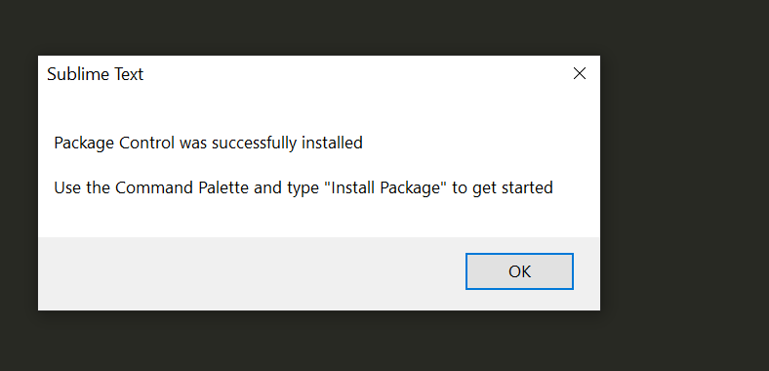

1. Again go to sublime text press cntrl+shift+p (windows), cmd+shift+p(macos) and type install and choose package control: install package and then press ok.

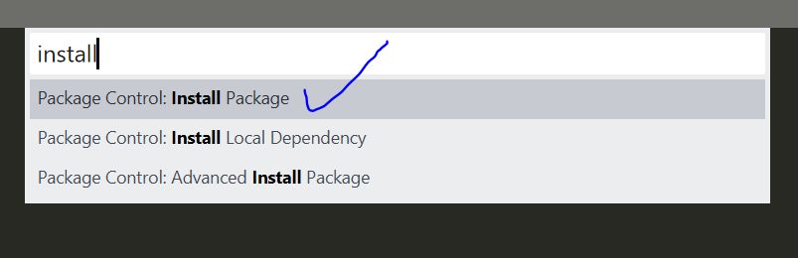

1. Now you get different plugins for sublime but we need emmet so type and emmet and hit enter key.

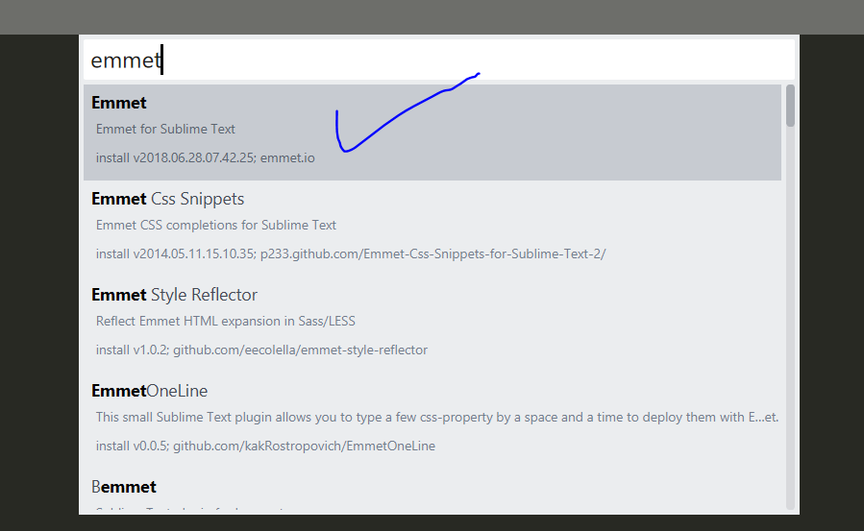

1. Once succeful downloading emmet on sublime quit sublime and restart.
2. 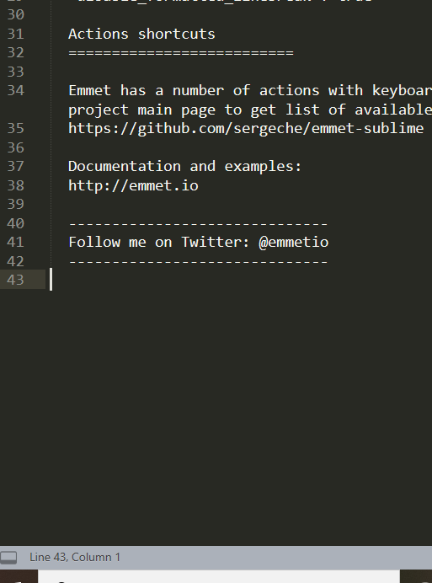
3. Now go to index.html file and type (!+tab) and get the basic html mockup as below:
4. 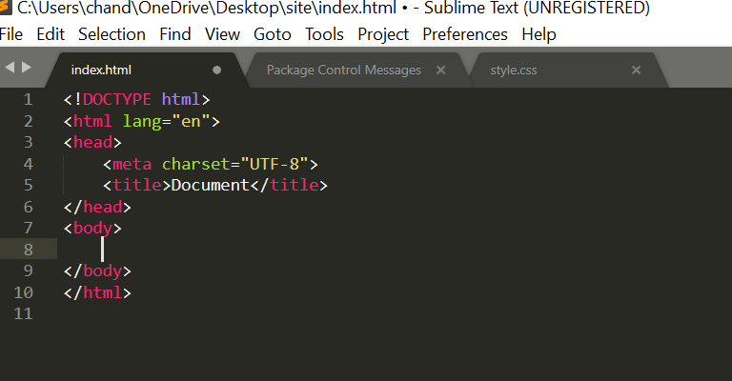
5. Change the title from Document to desired title..I’m using “take me ther”
6. Download Bootstrap 4, extract the files and copy bootstrap.min from css to css folder in site folder and bootstrap.min.js from js file to js folder site folder.
7. Faced an intense issue which I WAS TROUBLESHOOTING FOR HOURS..DUE TO WRONGLY CHOOSING bootstrap.min.js(MAP file) instead of bootstrap.min(JavaScript file) which CAUSED PROBLEMS LATER IN THE SECTIONS OF THE PROJECT I WAS STUCK AT CONNECTING TO ADMIN PAGE FROM THE DATABASE AS I WAS NOT ABLE TO GET THE FUNCTIONS WORKING DUE THIS SILLY MISTAKE I WAS TOTALLY TIRED AND ALMOST GAVE UP BUT I TOOK A BREAK FOR 30 MINUTES AND CALMLY CHECKED EACH AND EVERY FILE TO SEE IF ANYTHING IS CAUSING A PROBLEM GOOD I WAS TAKING SCREENSHOTS OF MY WORK AND TAKING NOTES WHILE I WAS DOING THIS PROJECT GOOD AFTER DOING GOOGLE SEARCHING AND INTENSE TROUBLE SHOOTING LIKE ADDING CDN ETC,.I FOUND THAT I ADDED MAP FILE BY MISTAKE WHICH IS USELESS HERE SO I QUICKLY REFFERD TO MY INITIAL STEPS ON MY DOC CREATED AND FOLLOWED TO COPY bootstrap.min FILE THIS TIME TO MY JS FOLDER ON THE PROJECT..VIOLA FIXED THE ISSUE.
8. 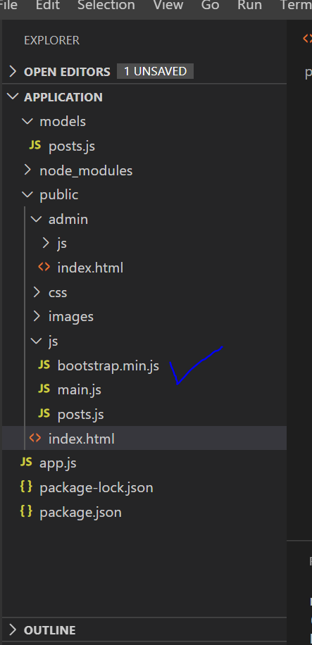
9. In index.html add the href links for both bootstrap and js as below:
10. 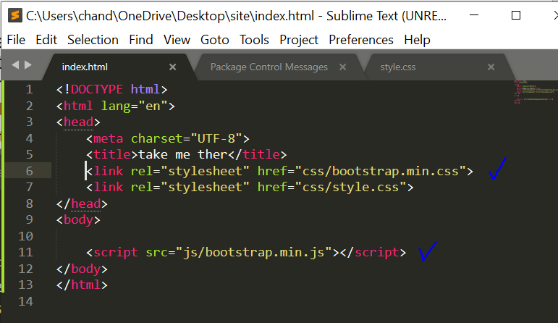
11. Now we need to connect to bootstrap we need to use jQuery and Popper.js via bootstrap CDN from download page of the bootstrap official site.
12. 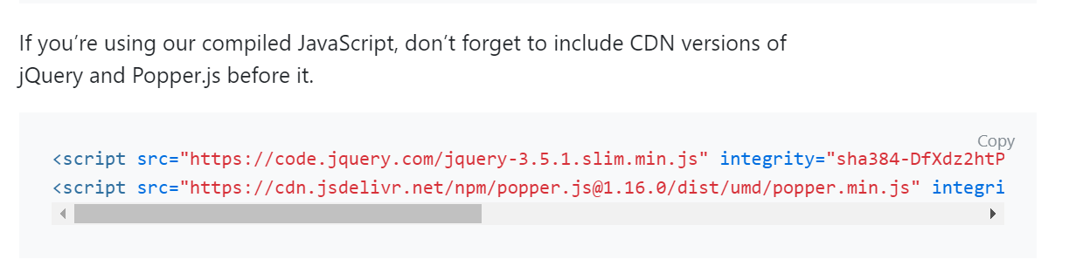
13. No add this in index.html file just above script tag for bootsrap.min.js as shown below:
14. 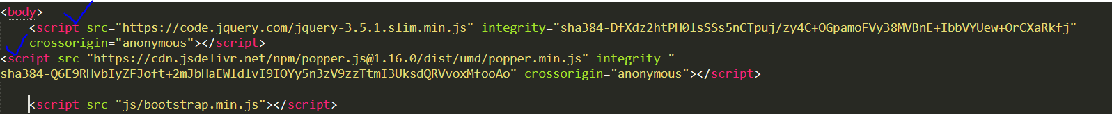
15. Now as the website will have a header, main and a footer we need to create that now inside the body tag in index.html.
16. 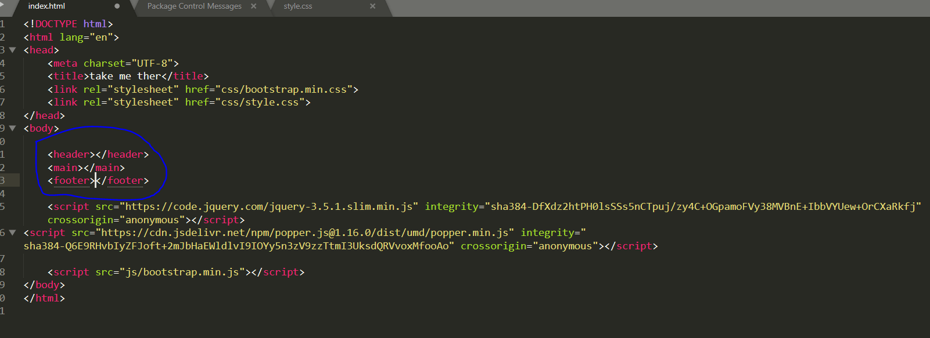
17. Now go to components and choose navbar and copy the script and paste inside header as shown below:
18. 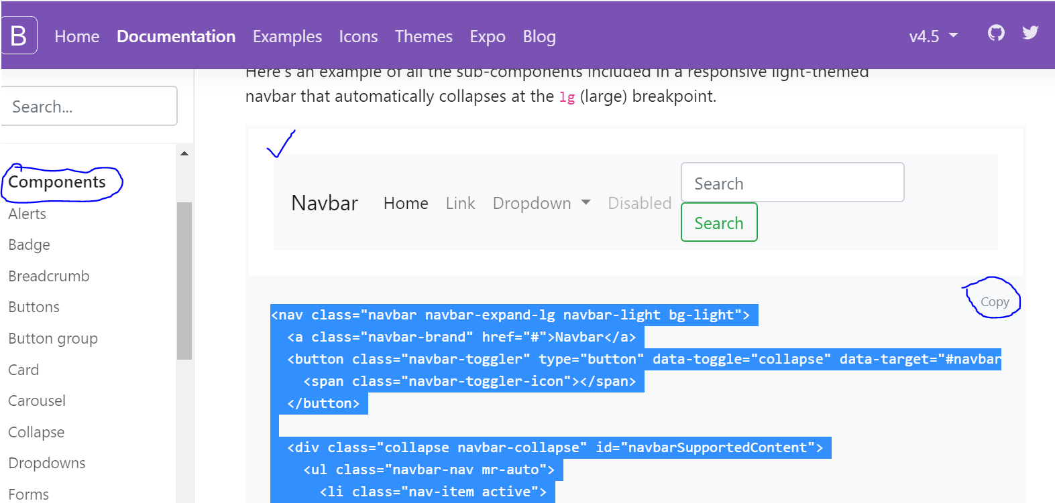
19. 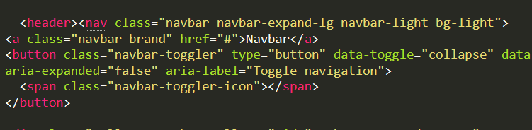
20. 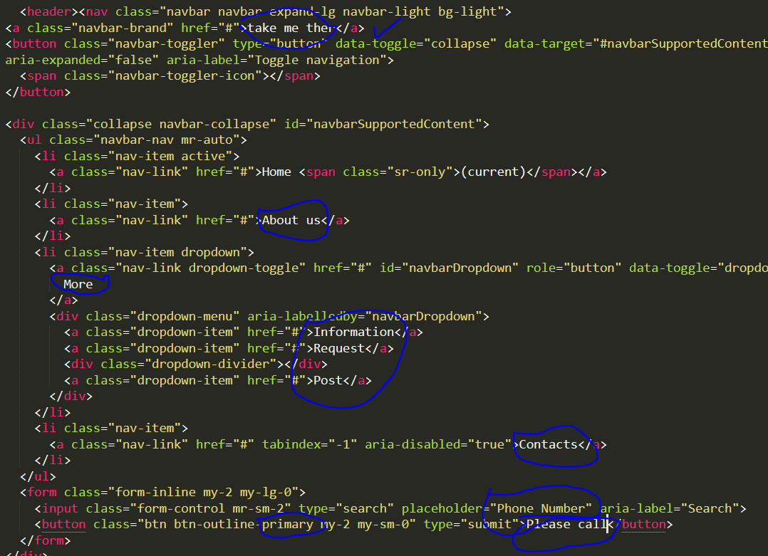
21. Now make changes to the above script in the header:
    1. Change Navbar to “take me ther”(website name)
    2. Retain Home
    3. Change Link to “About us”.
    4. Dropdown to “More”.
    5. Under Dropdown change the item to Information, Request and Post.
    6. Change Disabled to Contacts and remove ‘disable’ from class = “nav-link”.
    7. Change to Phone Number, Call me and add primary instead of success.
    8. And save.
22. Now right click and choose ‘open in browser’. And you’ll see the below page in internet explorer:

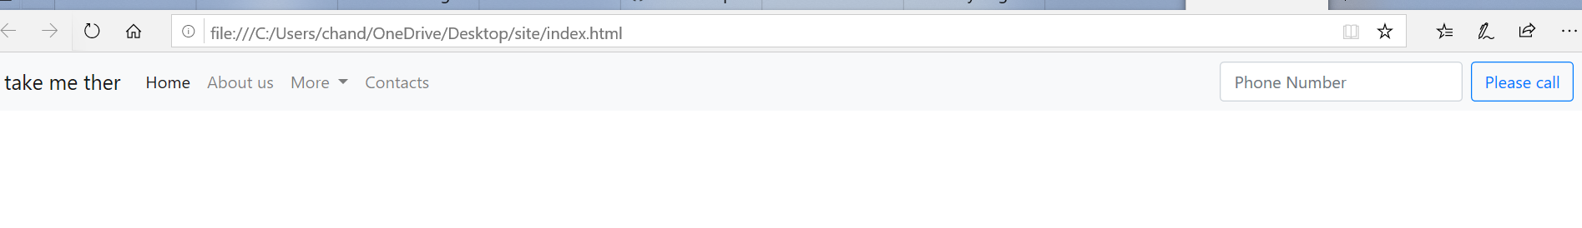

1. Now cut the content from <button> tag just below title and type .container tab to get <div> container to get above header in container to align better:
2. 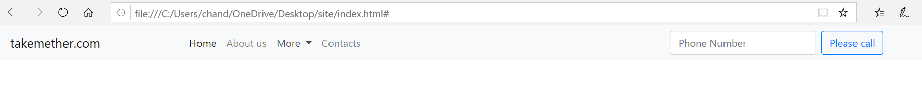
3. Now we need to add sliders to the website as we finished with the header above. For that we need to choose carousal option from the bootsrap official website.
4. 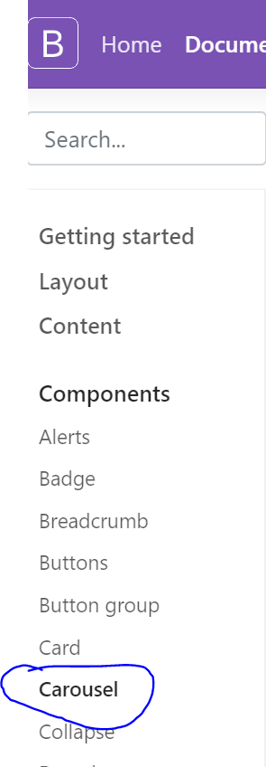
5. Choose the script for sliders with indicators and captions:
6. Now copy and paste inside main tags:
7. Now copy desired images and add them to ‘images’ file in the site folder.
8. Make changes to the index.html file for the image src, h5 tags and the caption as below:
9. 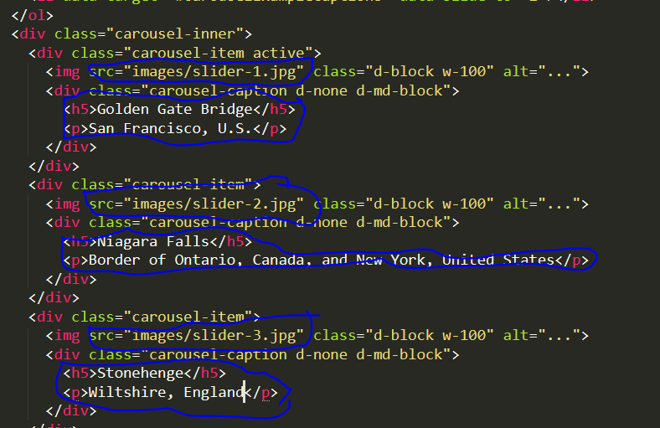
10. Had troubleshooting issues on slider fixed by researching and found on stackflow added the dependencies scrip for jquery and popper just below the title tag and remaining slider and caption script retained from the bootstrap website.
11. Now need to add grip for the post cards on the main page.
12. Type ‘.row+tab’ and get the div tage for the row and then type .col-4*6 for 6 columns.
13. Now add post card details to each column as below: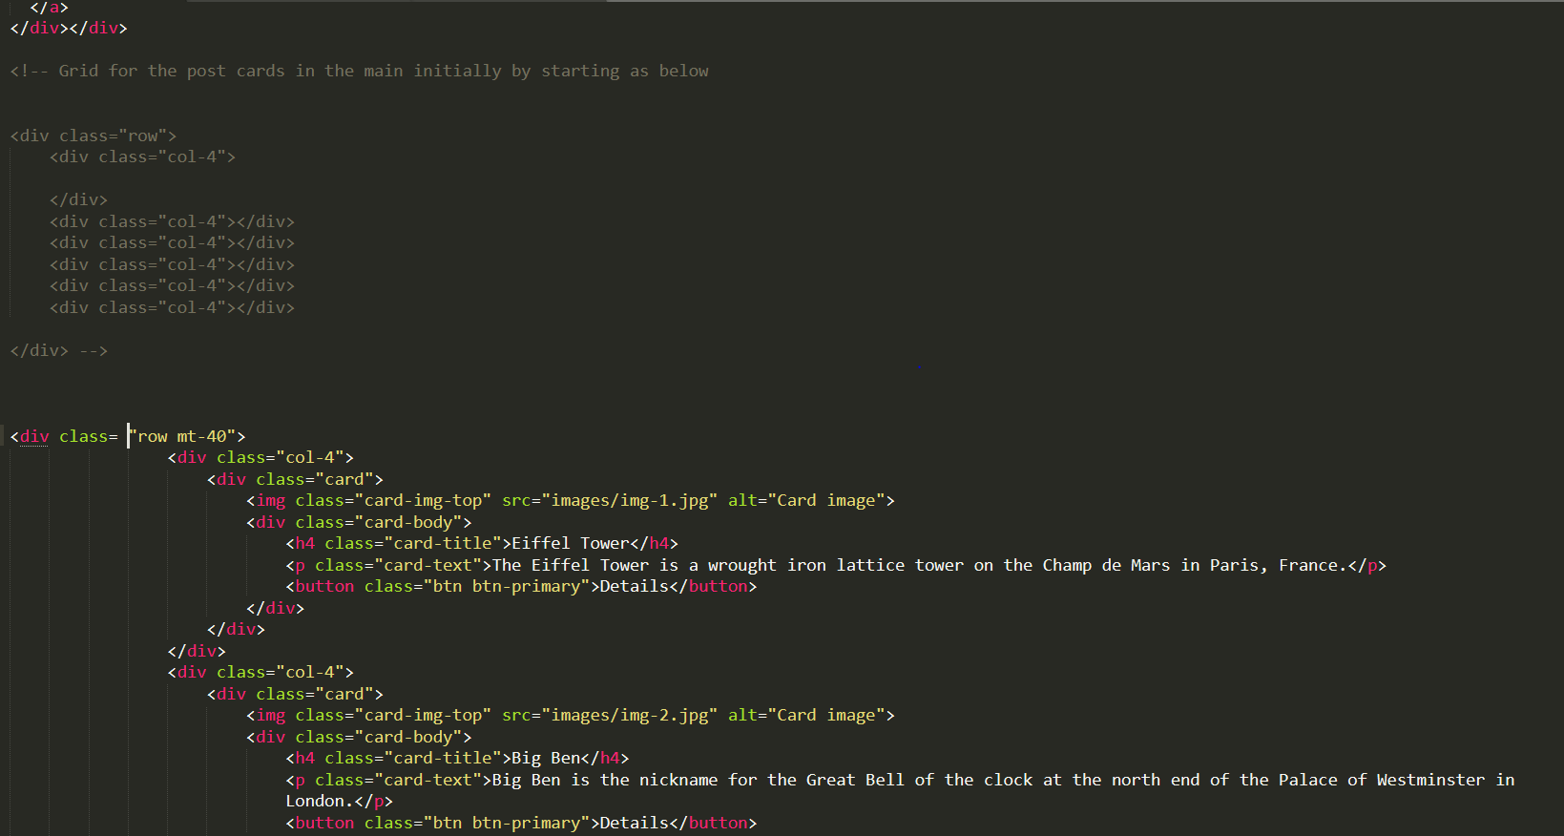
14. Add this:
15. 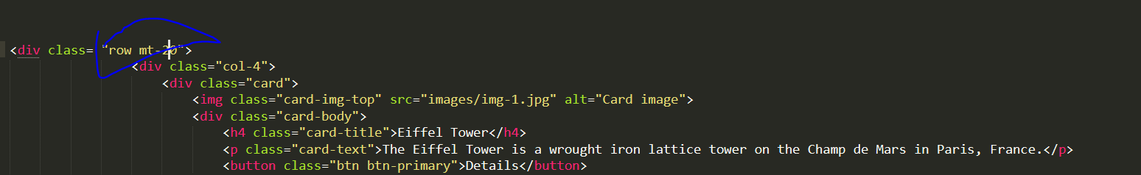
16. 
17. 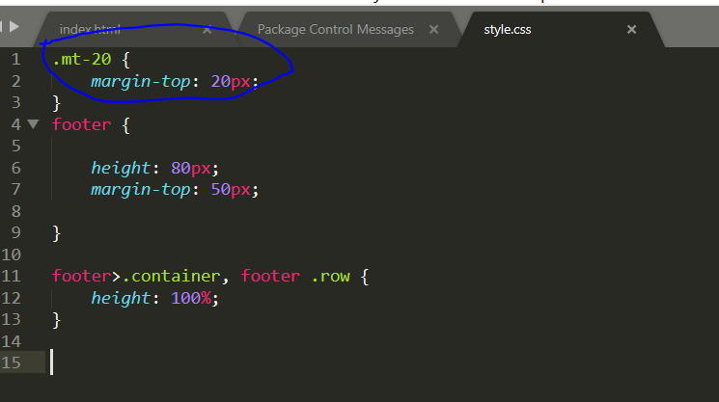
18. Now Footer is aligned as below:
19. 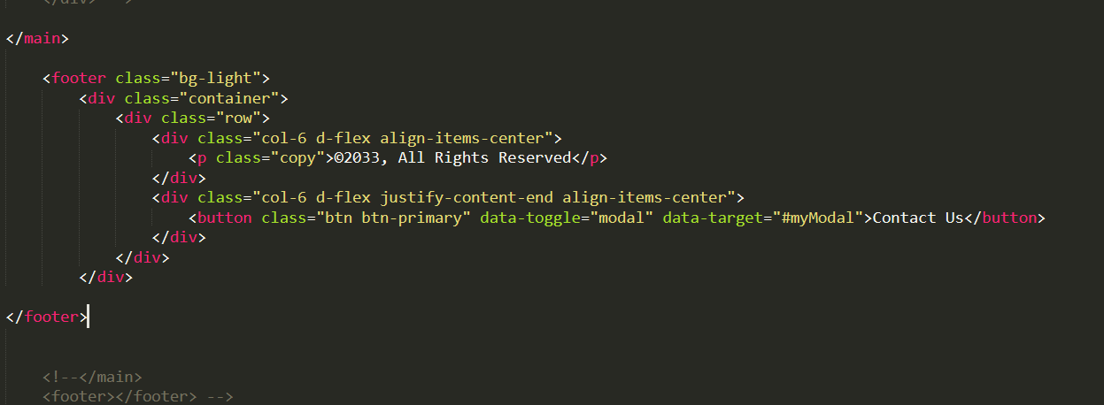
20. Need to get form when we click Contact us, so for tht go to Boostrap official site and look for Modal and copy and past the script content just after </main>:
21. 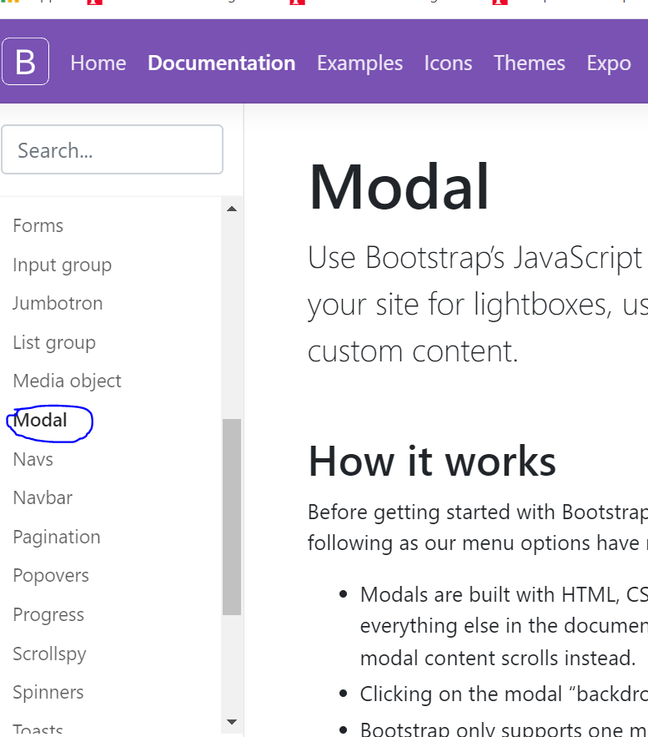
22. 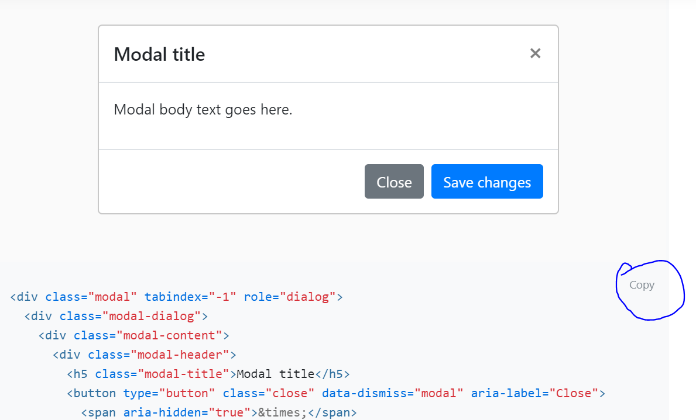.
23. Now make changes as per desired name , content or color.
24. Now need to get a form when click Contact Us, so go to forms on bootsrap site and copy the basic form contents for each desired form entity separate ex for email address, name, message..etc
25. 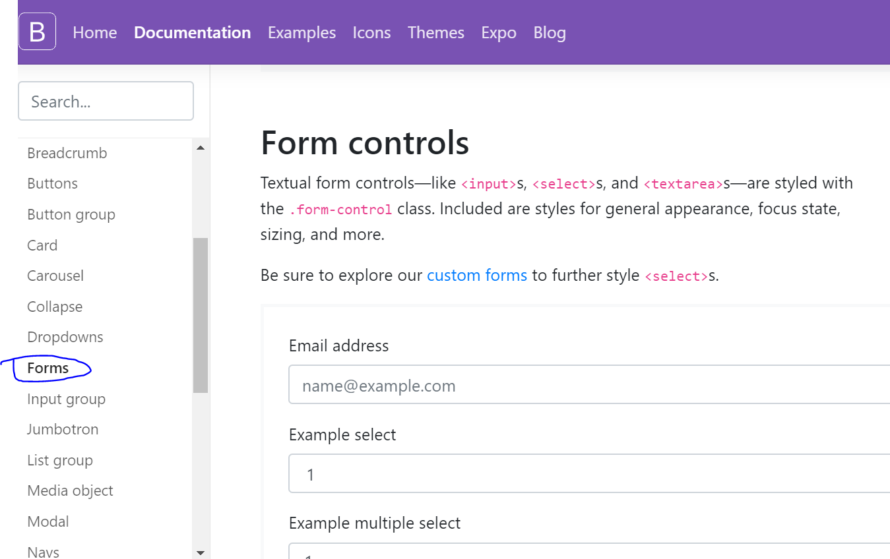
26. 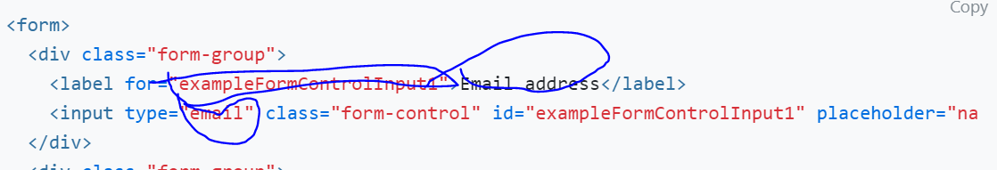
27. In the above remove email address options as we don’t want email so instead change it for the name options:
28. 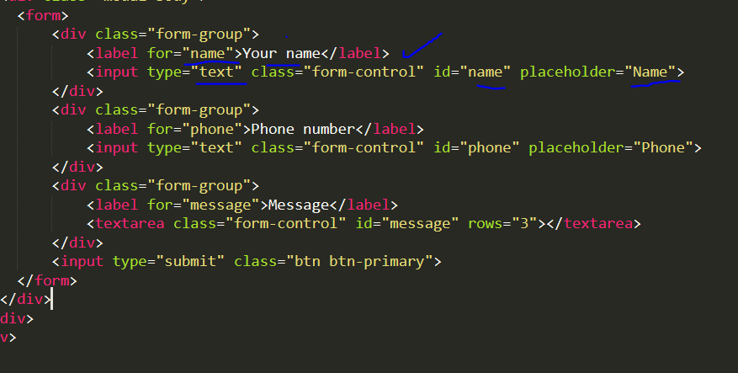

Takemether.com advanced steps:

1. Now we need to transfer files from sublime text to VS Code as we are going to use VS Code for that open a folder in the desktop and open the same from VS Code.
2. Create application folder on desktop, open it from vscode, now open another folder ‘public’ inside application from vscode, now copy all the files from site to public.
3. Create a file called app.js inside application folder not public and go to terminal and type npm init -y:
4. 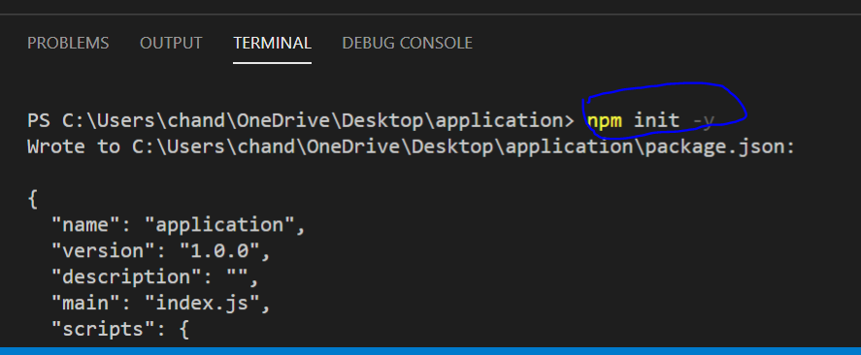
5. This will create package.json file:
6. 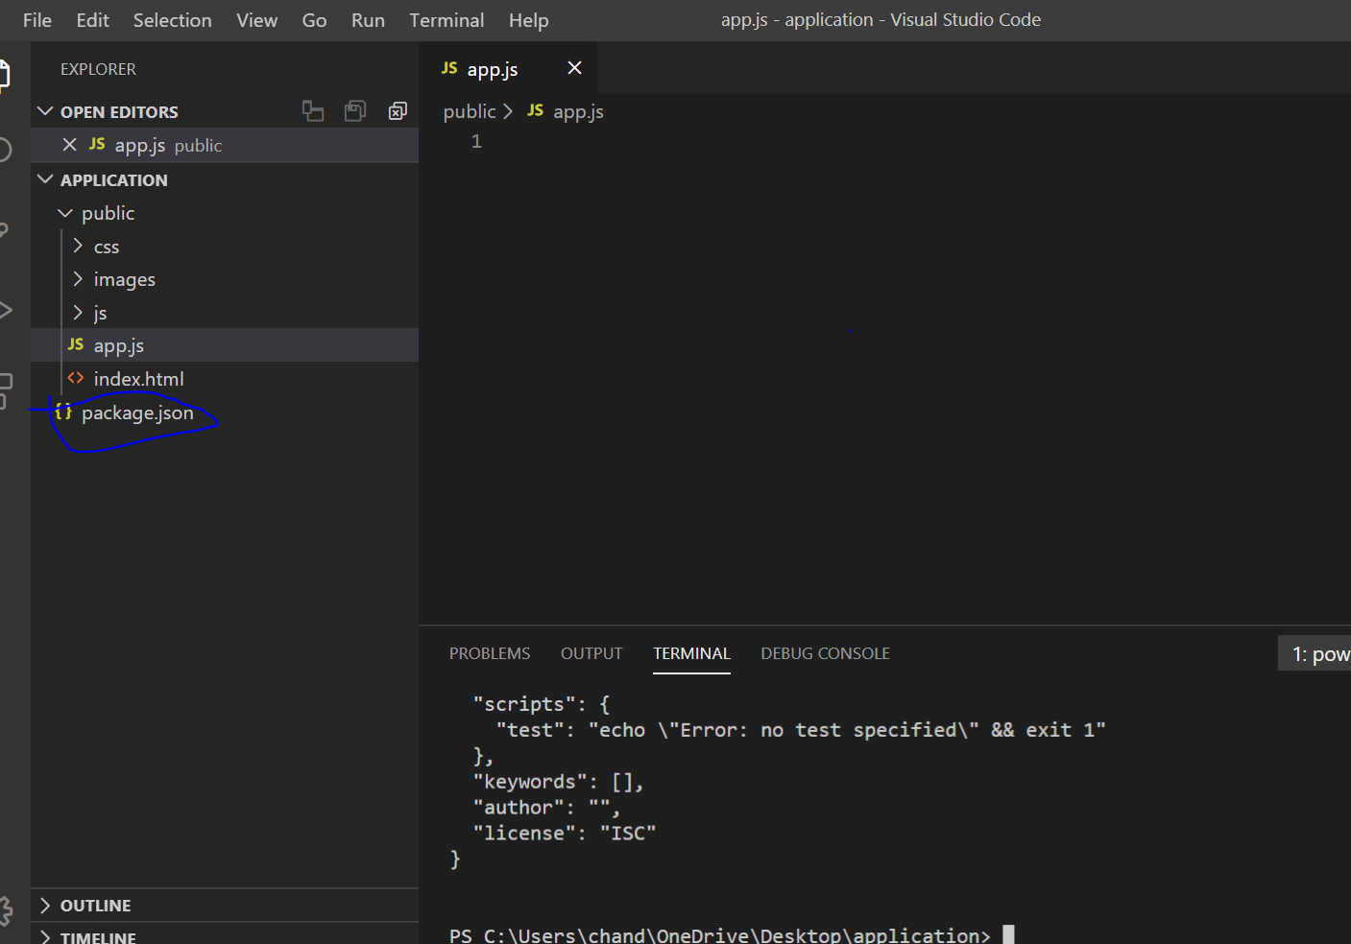
7. Now install express package by using npm i express:

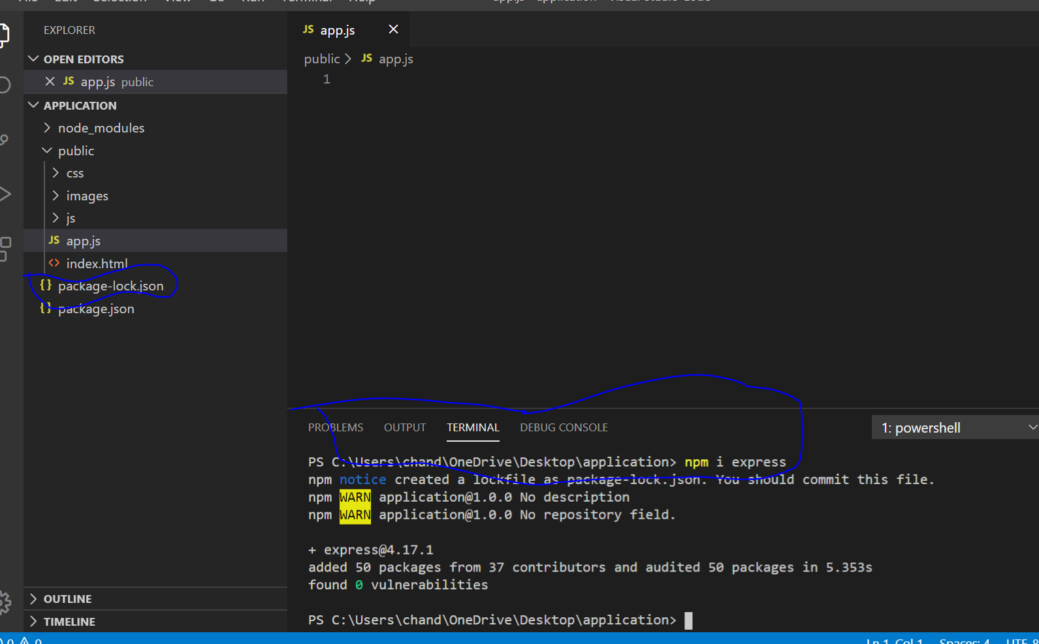

1. Now we need to connect express to app.js by writing the following script in app.js file
2. We are calling express and storing in variable express and saving that in app variable.
3. Now setting port 3000 and using call back function to set port 3000.(need to learn more on this step.
4. let express = require('express');
5. let app = express();
6. app.listen(3000, ()=> console.log('Listening 3000...'));
7. 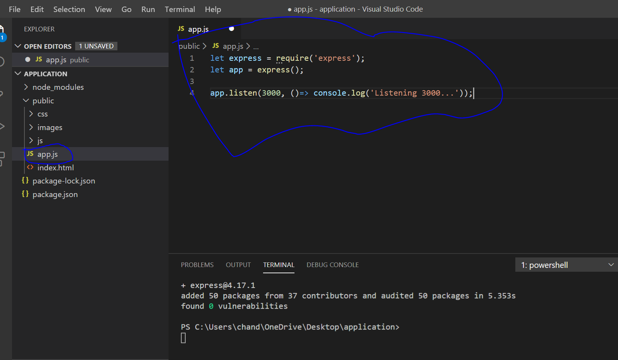
8. Now to check if the port 3000 set type node app.js:
9. As initially app.js was created under public folder when ran node app.js gave error so did troubleshooting and finally changed the folder app.js from public to application as given below:
10. 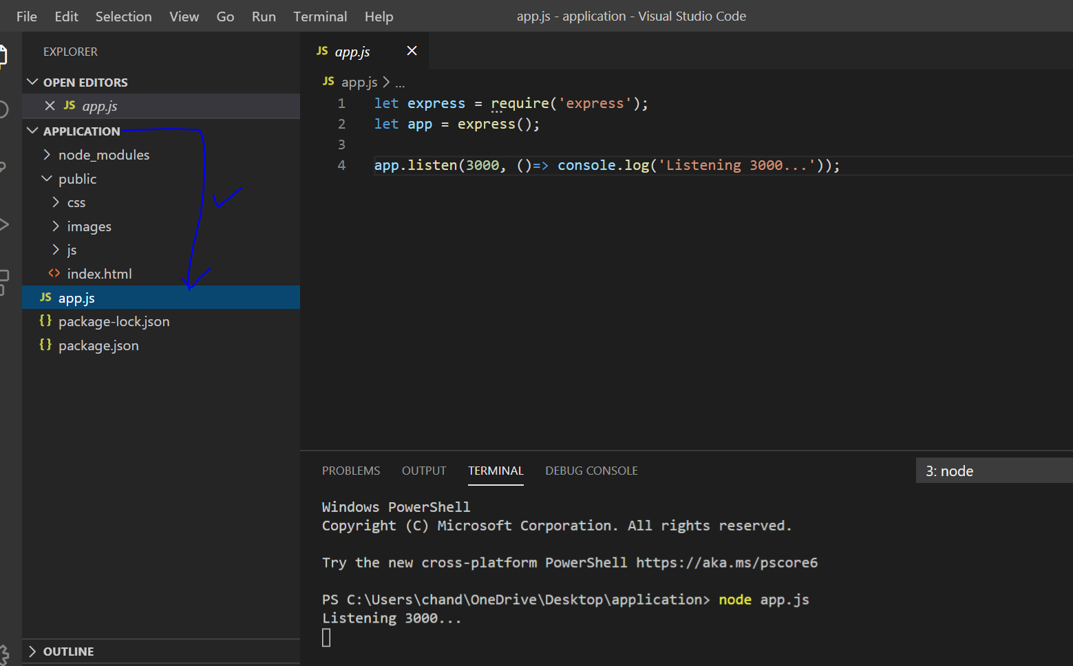
11. And now when type node app.js it worked showing the message ‘Listening 3000..’
12. Now check if the local host is listening by typing ‘localhost:3000’ in the browser:
13. 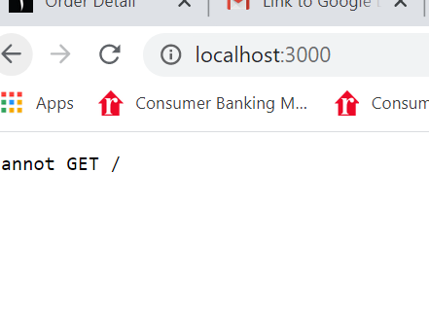
14. We get Cannot Get / message now we need to connect the express with the index.html file.
15. Now we type the below ‘use method’ or function on app and provide public folder as an argument. in app.js filr to connect public folder as it contains all the site files:
16. app.use(express.static(‘public’)); This will connect the static files to app.
17. 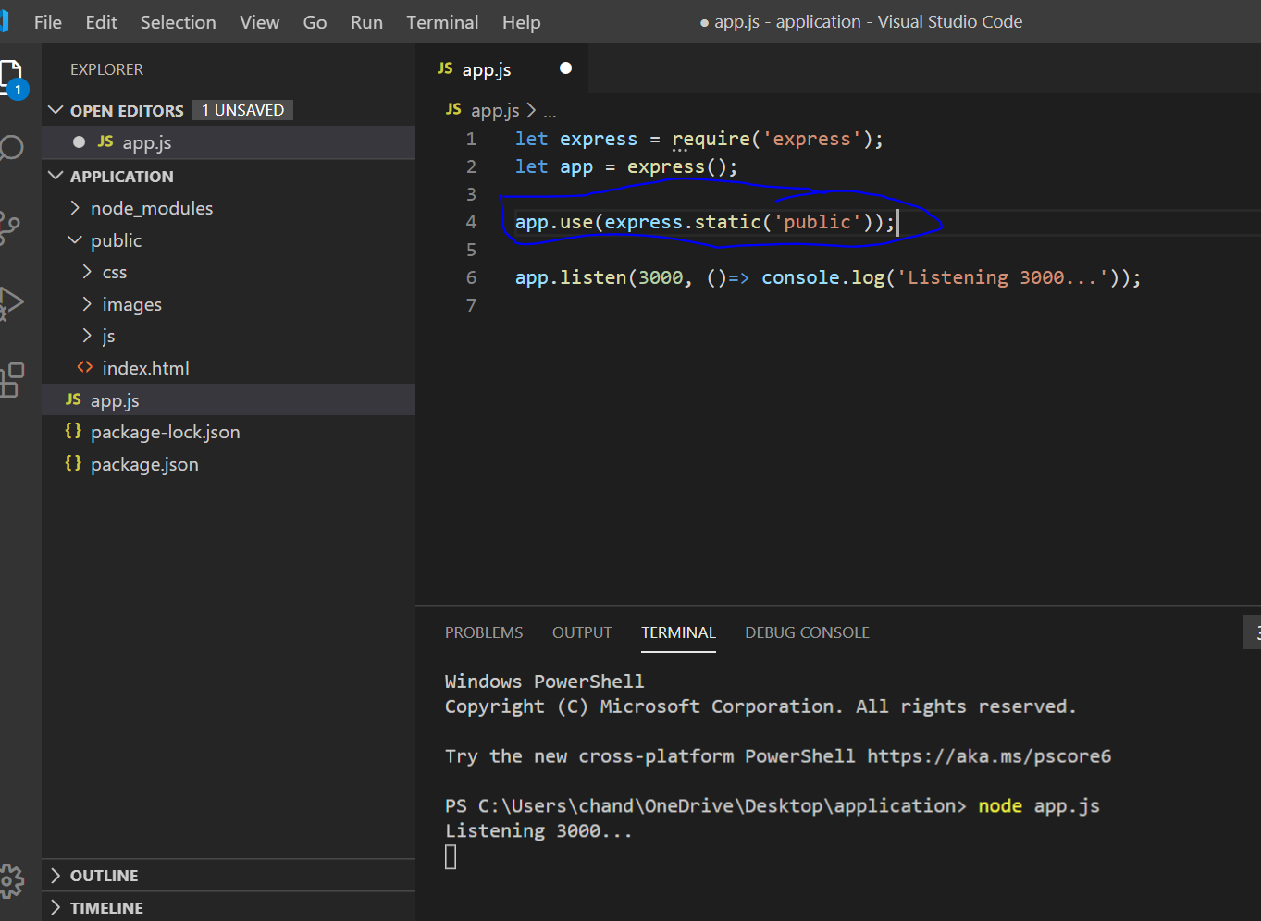
18. Now refresh and type node app.js and check the browser it should connect to public with site files for the takemether.com website files.
19. I got an error that port 3000 is already in use so changed the port to 3004:
20. 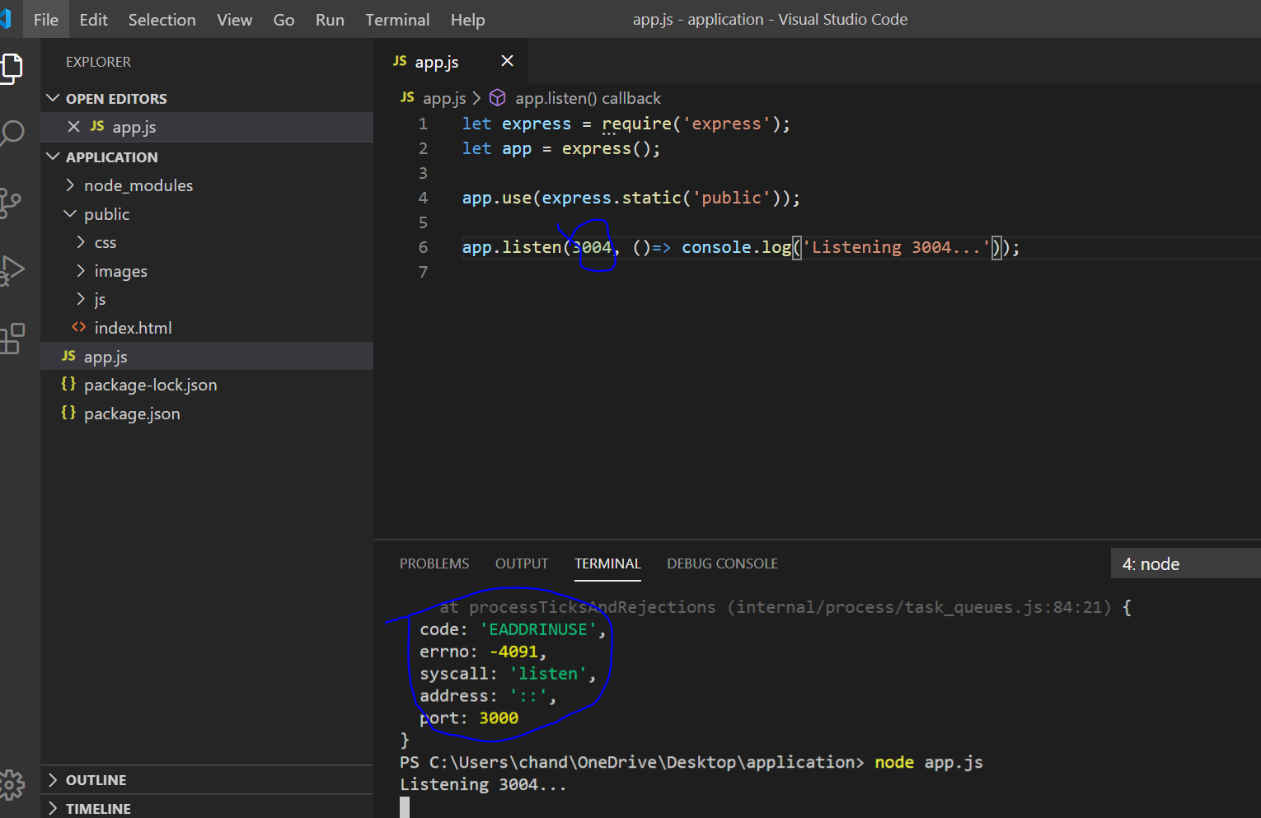
21. Now able to see the pages from public on the browser after typing ‘local host:3004’.
22. 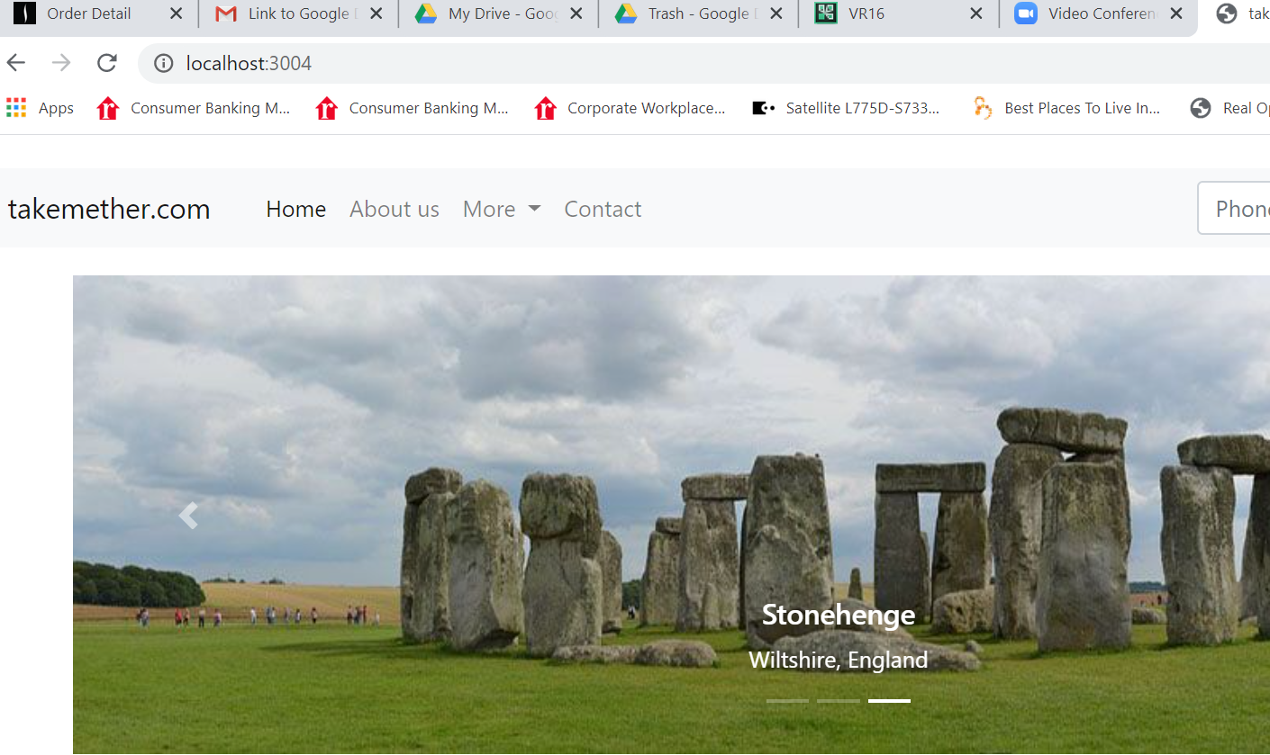
23. Now need to add ‘Admin’ to the main page. So go to index.html under main add the below copy the script part for the contact and paste below it and make changes to the name as’Admin’ and keep link as href= ‘/admin’ once you click Admin on the main page it’ll go to Admin page but right it’s going to be blank: 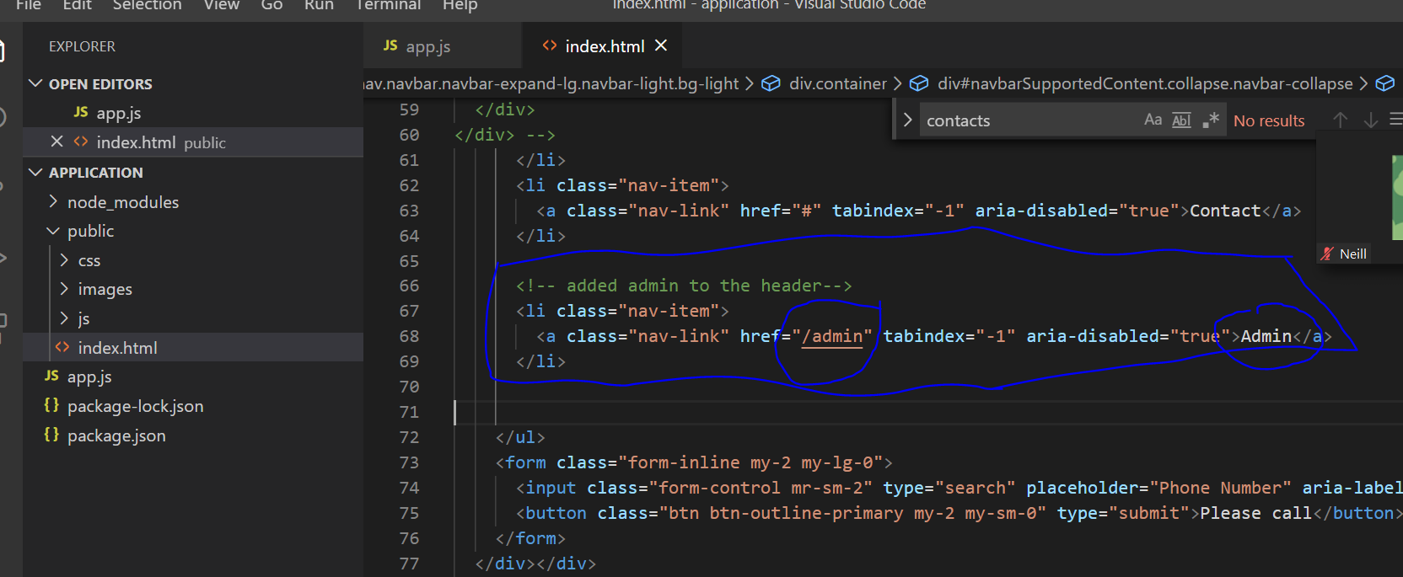

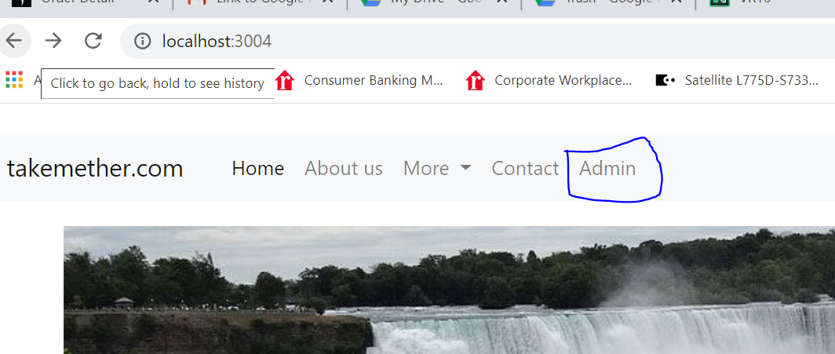

35.

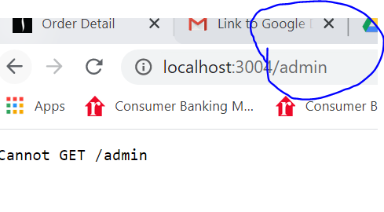

1. Now we need to work on creating the inside of Admin Page. For that we need to connect bootstrap and style.css to the admin page to get all the dependencies of bootstrap and style.css.
2. Under index.html in the admin folder inside the body tags type the below links:
3. 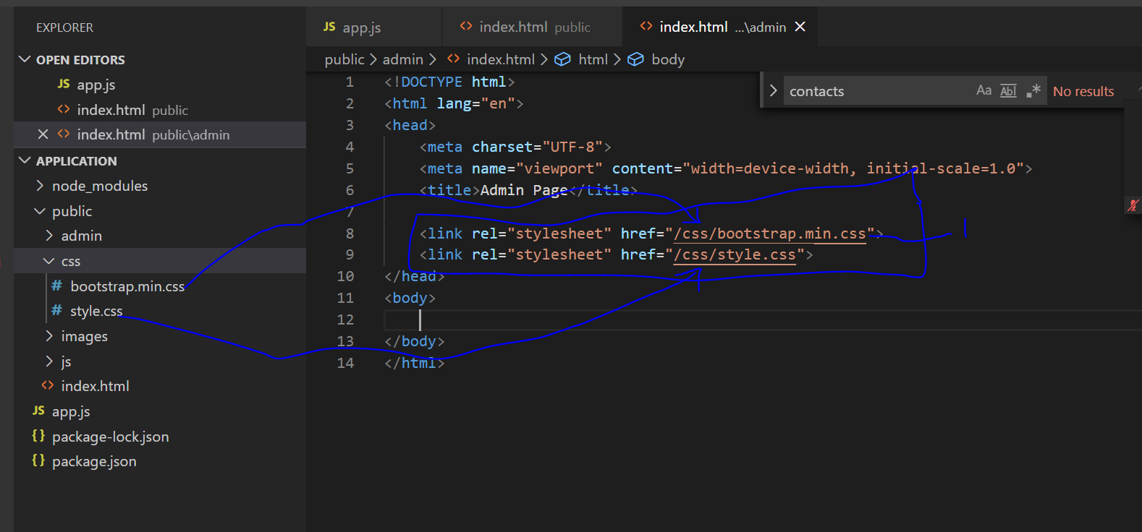
4. Now need to add header so copy the header part of previous index.html ie under site or public folder and copy here in admin page index.html as below:
5. 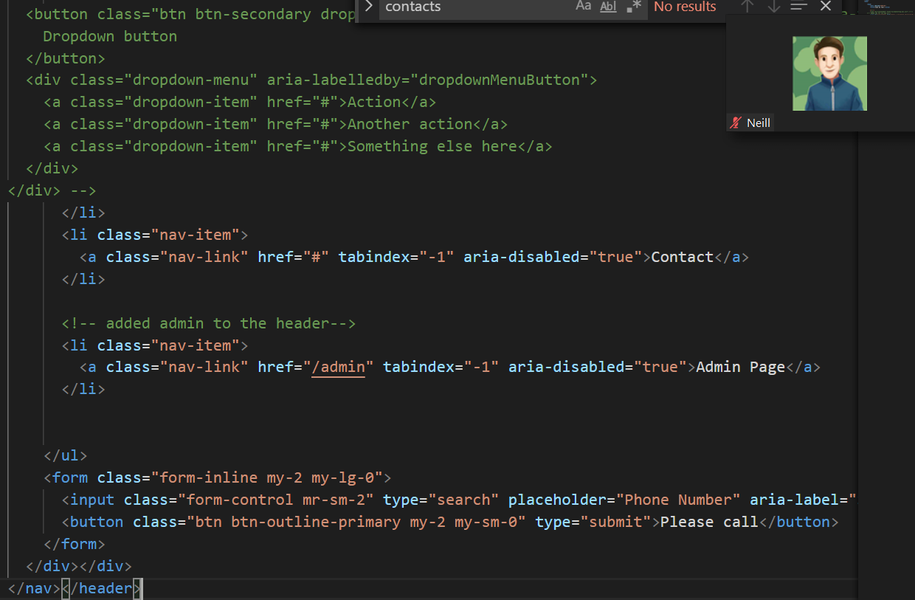
6. Now when we go to browser and click admin page we get the below but we need to change the names in the header.
7. 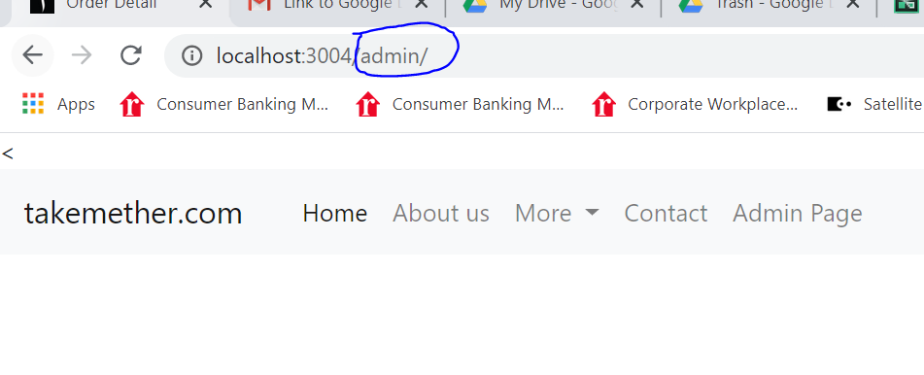
8. 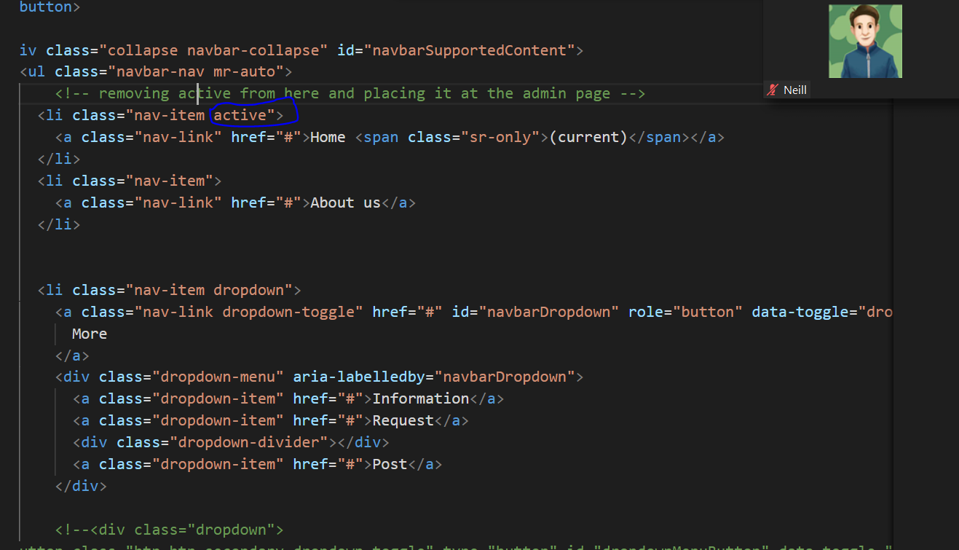
9. 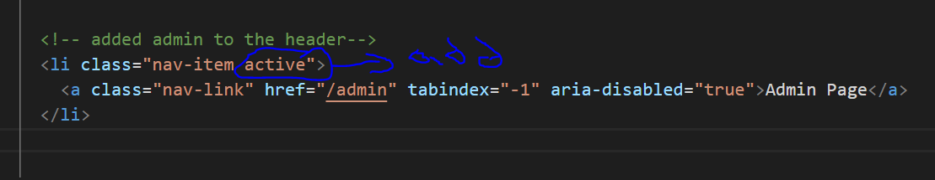
10. 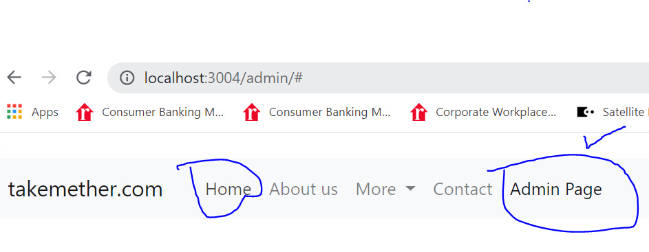
11. Above the menu item Admin Page is active now and Home is inactive.
12. Now we need to go to home page when we click at Home menu item and also when click at takemether.com on the menu bar for that we need to add link as ‘/’ which redirects to the current folder ie public folder as the index.html file is in public folder so we make changes as below:
13. 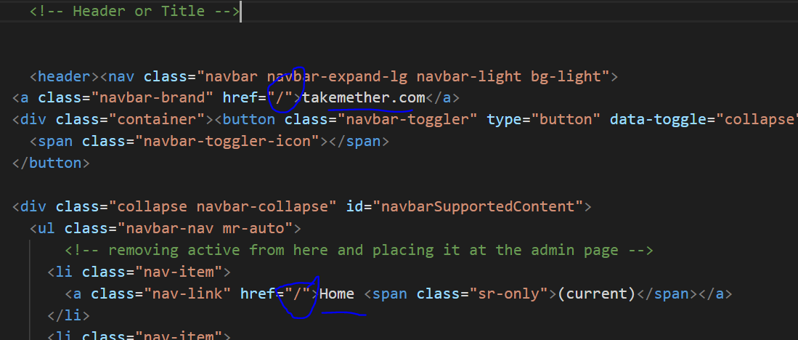
14. Now add these to the Admin page for the vertical pills, go to bootstarp website and choose Navs and choose the below and paste it in inbdex.html for the admin file:
15. 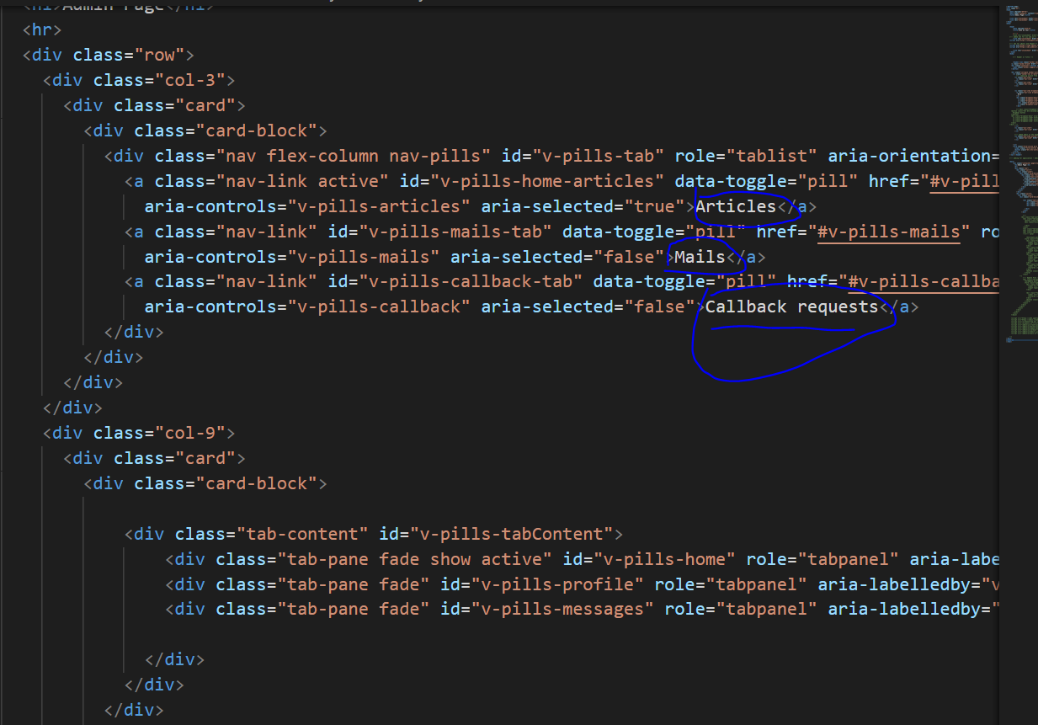

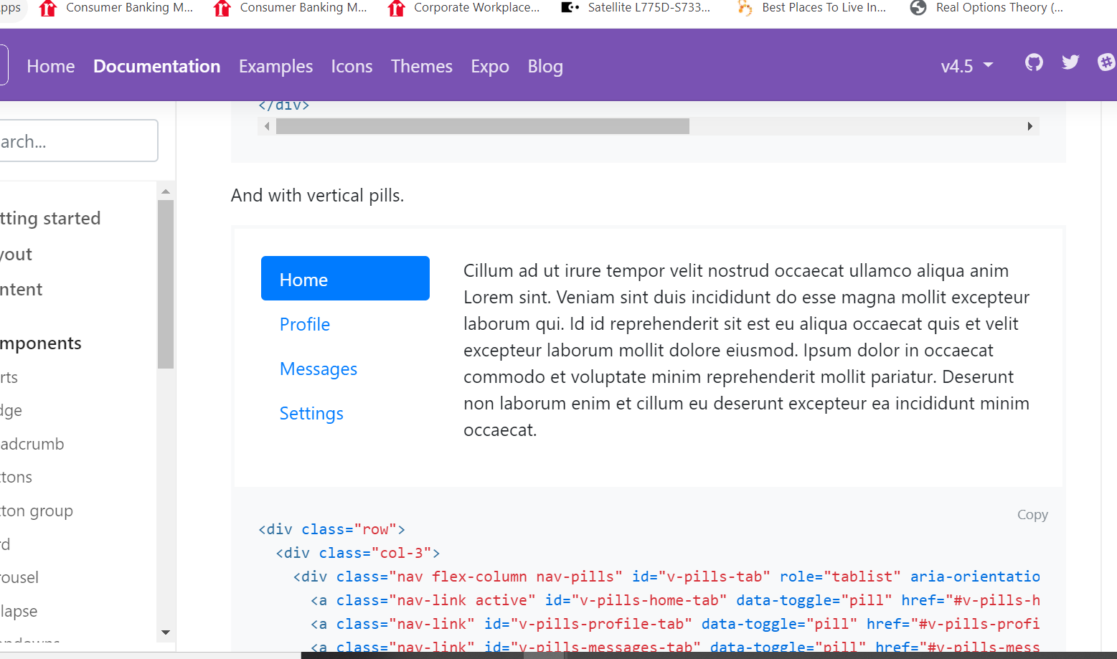

1. Now for the buttons to work connect bootstrapL
2. 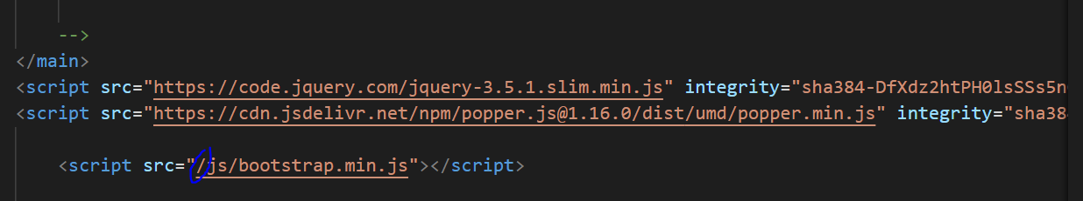
3. 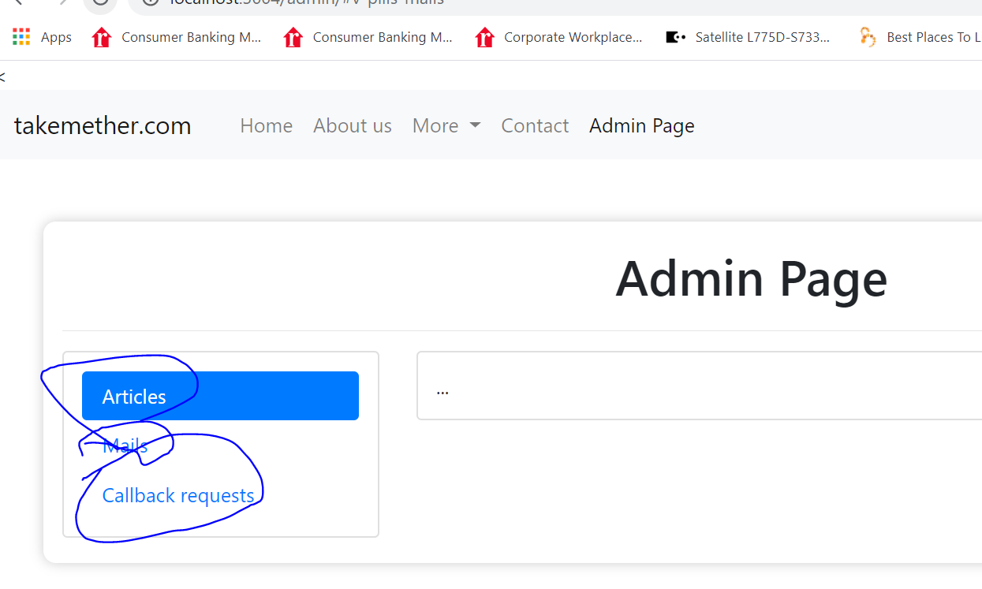
4. Now add the links from the site to the index.html for the admin to connect the bootstrap.
5. Don’t forget to make it active to see it working:
6. 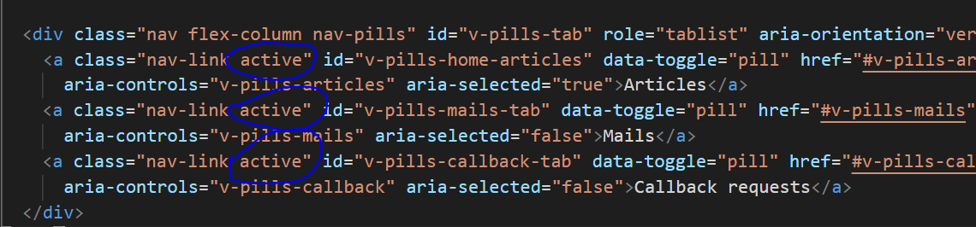
7. Did intense troubleshooting to get the list or the verticles pills reflect on the rhs content box upon clicking as below: Had to do adjustments as given in the <!....> mostly took the content directly from the bootstrap oof website.
8. 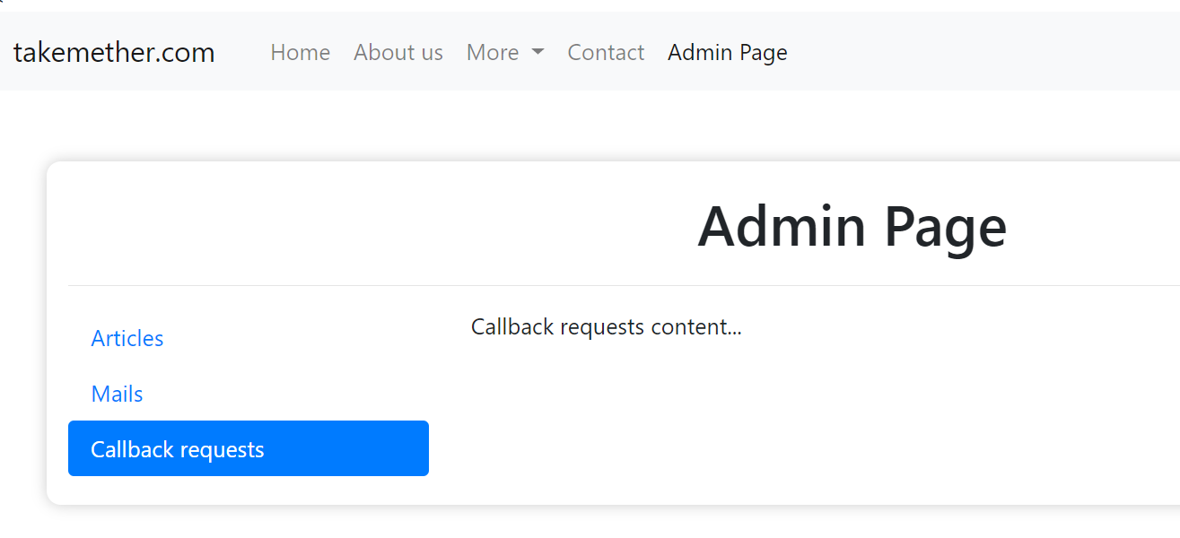
9. Now need to work on the content of the list via Post button.(sec 274)
10. Now remove the ‘Articles’ from the content script and the same div tag adda button called ‘Add Post’.
11. 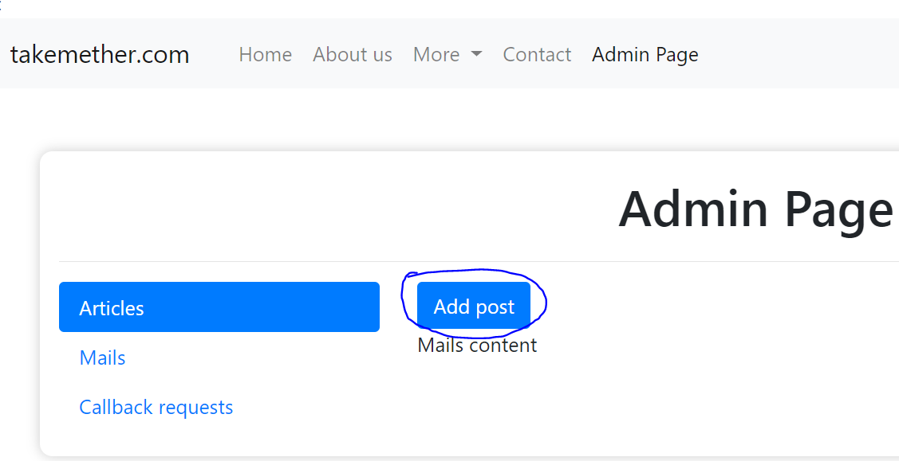
12. 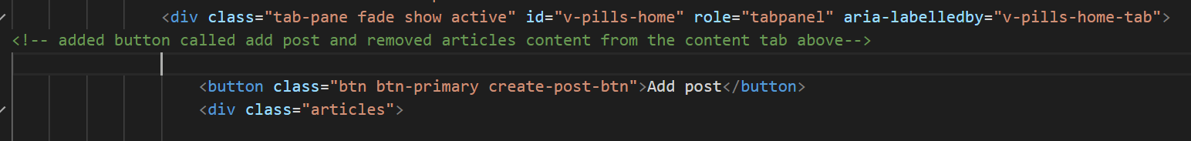
13. Now add the each list item to the index.html:
14. <div class="articles">
15. <article class="d-flex justify-content-between">
16. <div class="id"></div>
17. <div class="name">Eiffel Tower</div>
18. <div class="date">2021-Nov-11</div>
19. <div class="country">France</div>
20. <div class="edit">button class="btn btn-link">Edit</button></div>
21. <div class="remove">button class="btn btn-link">X</button></div>
22. </article>
23. 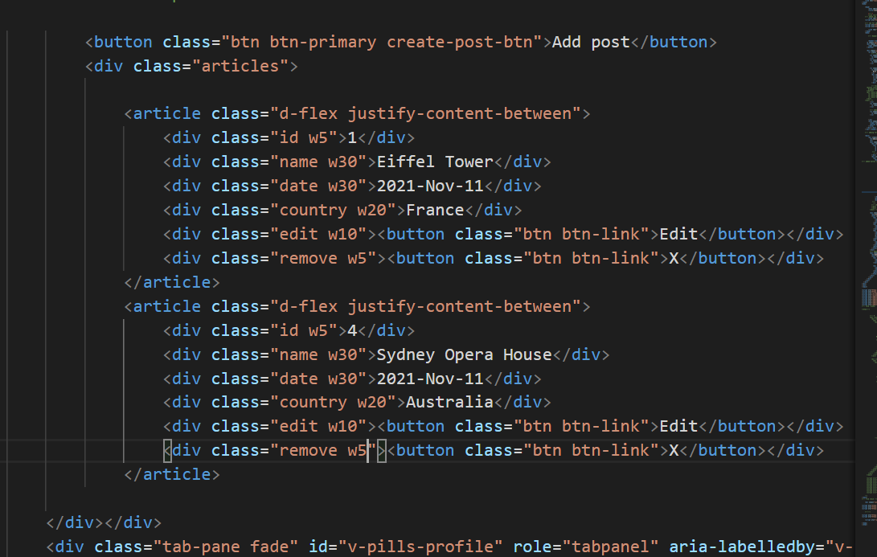
24. 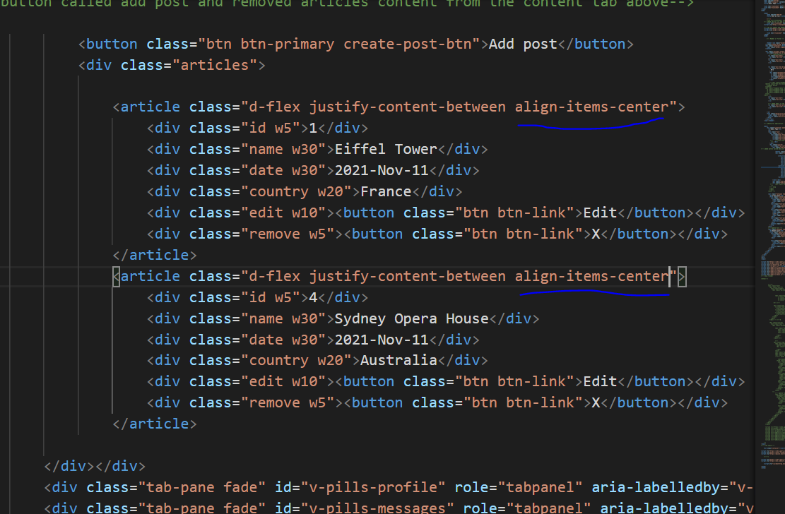
25. 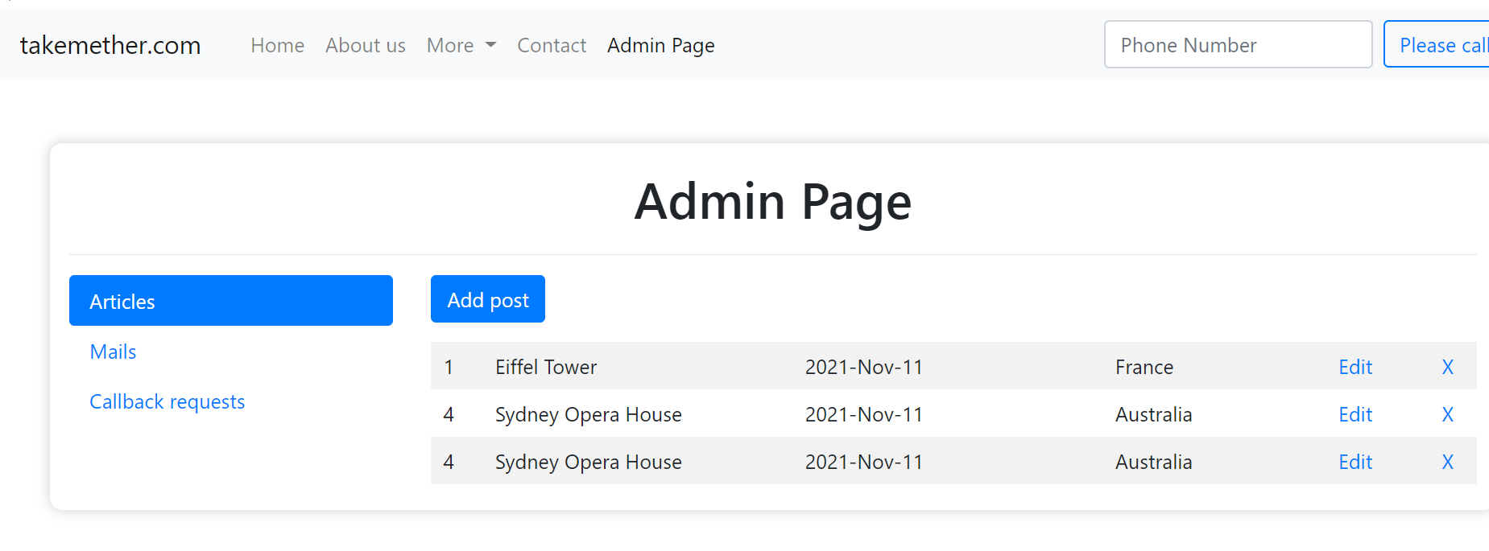
26. 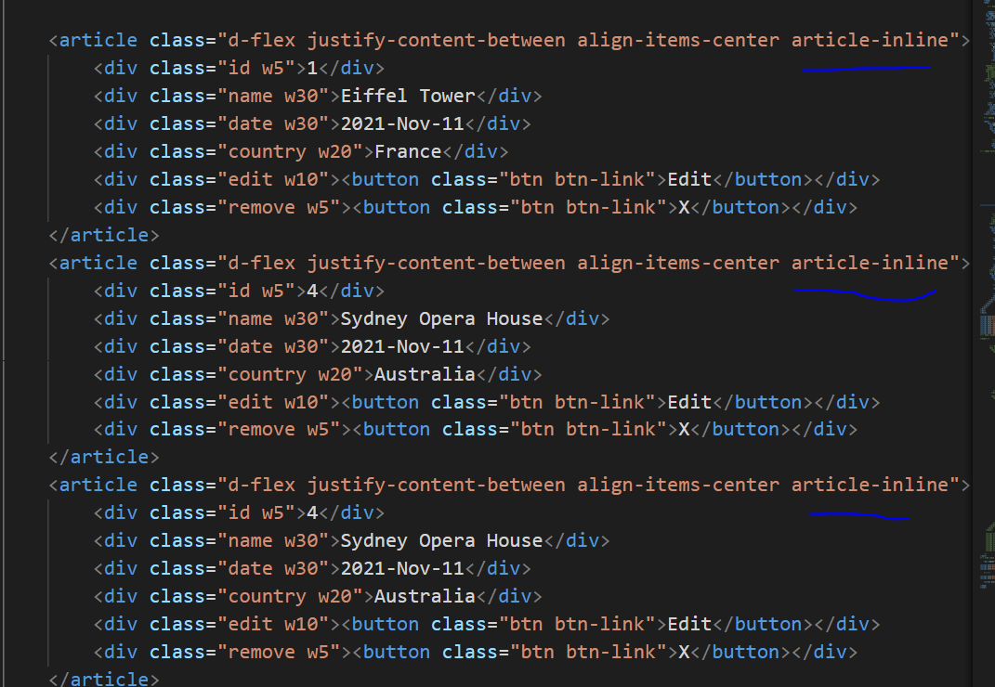
27. Creating a DATABASE and POST Model:

**Install** the extension

1. **MongoDB** support for **VS Code** is provided by the Azure Cosmos DB extension. To **install** the Cosmos DB extension, open the Extensions view by pressing Ctrl+Shift+X and search for 'cosmos' to filter the results. Select the Microsoft Azure Cosmos DB extension.
2. <https://code.visualstudio.com/docs/azure/mongodb#:~:text=Install%20the%20extension,Microsoft%20Azure%20Cosmos%20DB%20extension.>
3. <https://marketplace.visualstudio.com/items?itemName=mongodb.mongodb-vscode>
4. Press install and follow the instructions for the vscode market place and you see the below: Press Install.
5. It is important that we distinguish these two terms individually. Database schema is the skeleton of database. It is designed when the database doesn't exist at all. Once the database is operational, it is very difficult to make any changes to it. A database schema does not contain any data or information.
6. A database instance is a state of operational database with data at any given time. It contains a snapshot of the database. Database instances tend to change with time. A DBMS ensures that its every instance (state) is in a valid state, by diligently following all the validations, constraints, and conditions that the database designers have imposed.
7. <https://www.tutorialspoint.com/dbms/dbms_data_schemas.htm>
8. 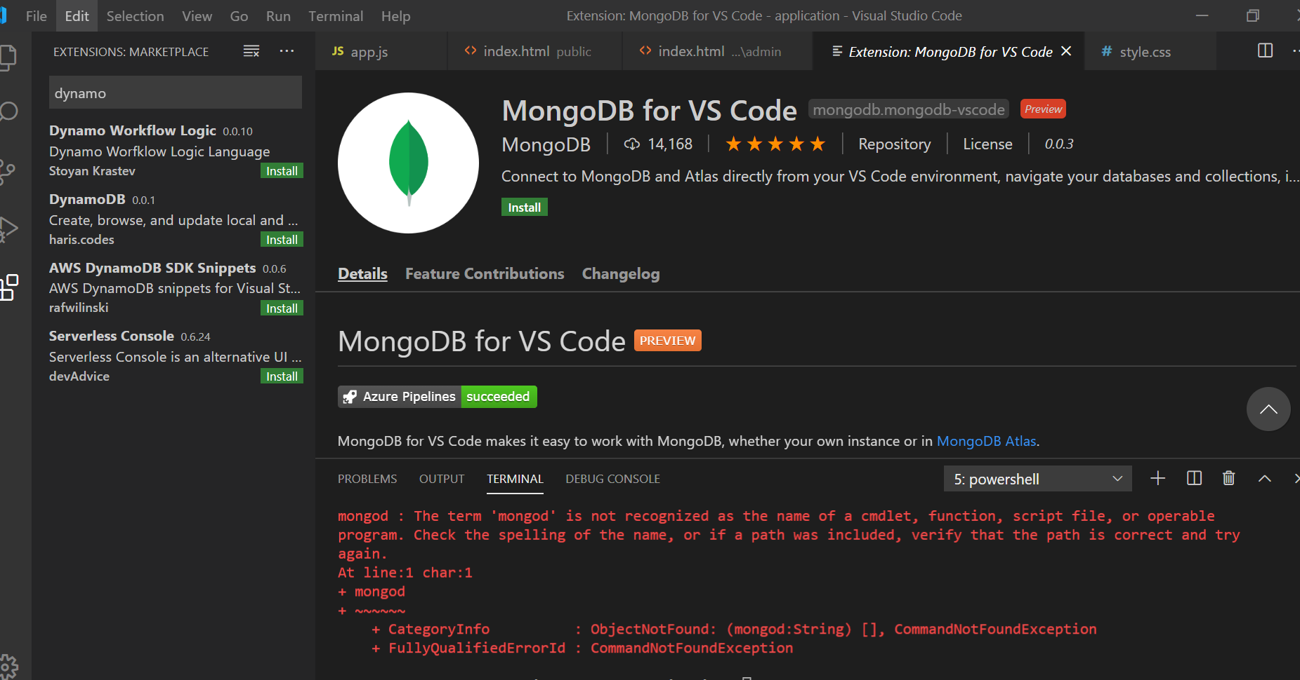
9. <https://cloud.mongodb.com/v2/5edf0696b9b528099625749c#clusters>
10. Download MongoDB from
11. [www.mongodb.com](http://www.mongodb.com) and open powershell and type mongod if you see error then follow the steps in the notebook to paste the path:
12. Then restart and try again mongod in ps:
13. 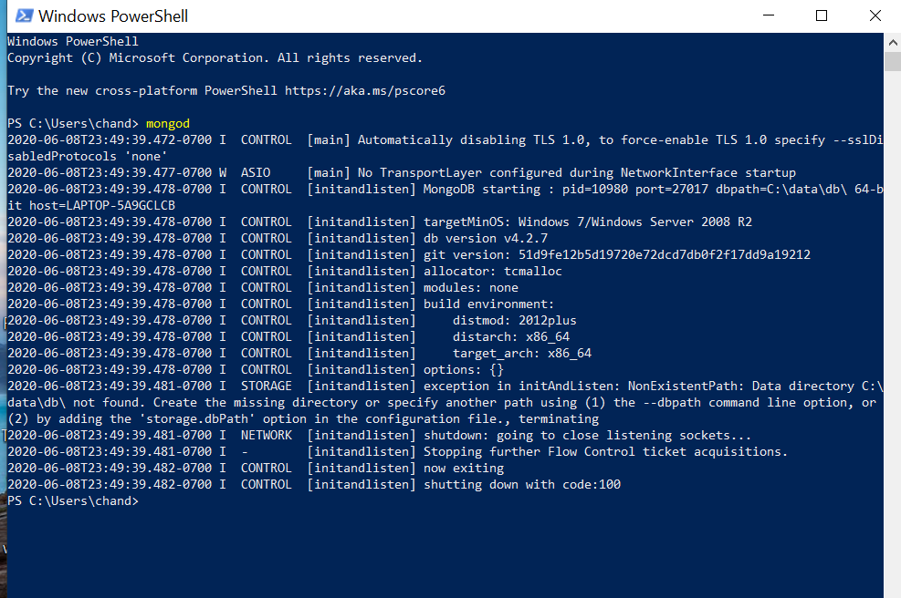
14. As we see the error code 100 we need to create a folder in c drive where momgodb can stores all it’s database files
15. Mkdir c:\data\db:
16. 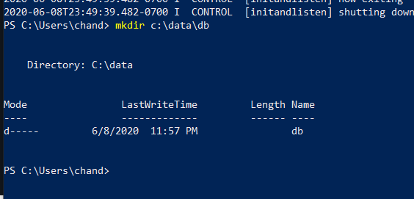
17. Now type mongod in PS as in the above the folder has beed created and you should see as:
18. 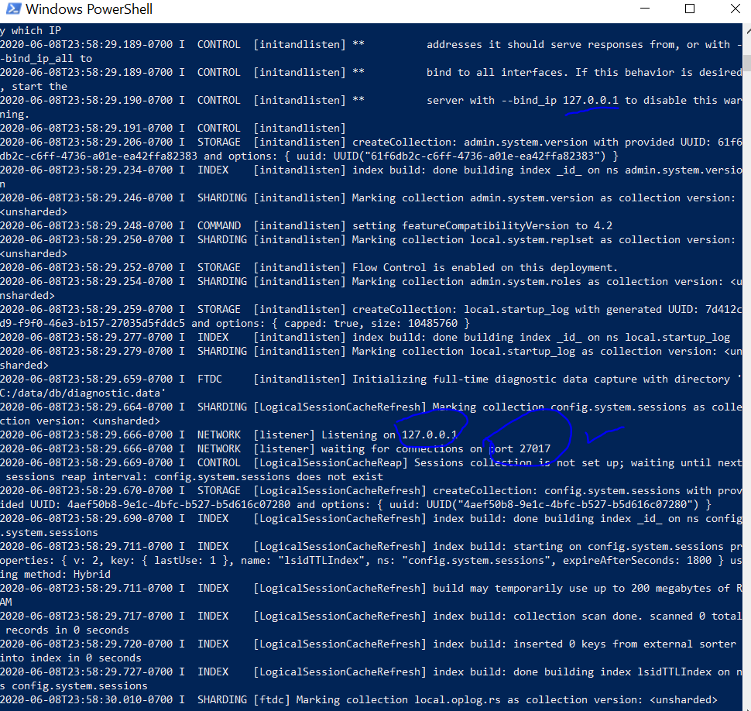
19. It shows the port number as 27017 which is for MongoDB hence mongo db is installed.
20. Now download MongoDb compass just follow instructions finally you see:
21. 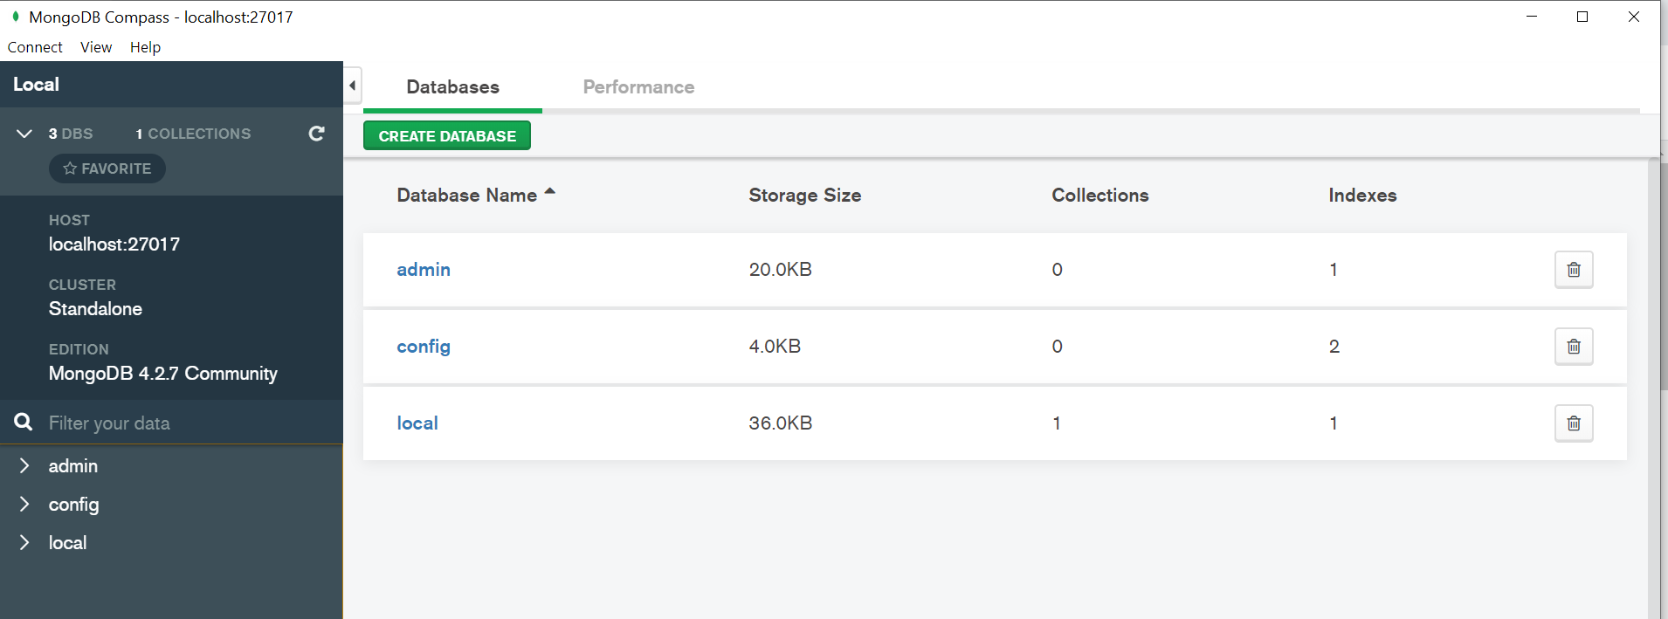
22. Running mongoDB on VSCode:
23. Now try mongod on VSCode make sure you close the desktop ps window otherwise you’ll get error 100.

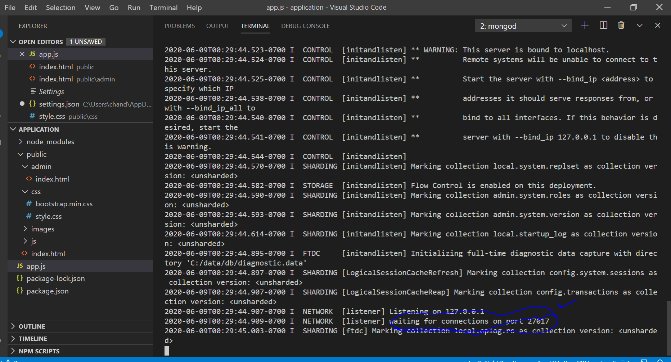

1. Create database on MongoDB Compass on the windows desktop DB name: travels and Collection Name: posts:
2. 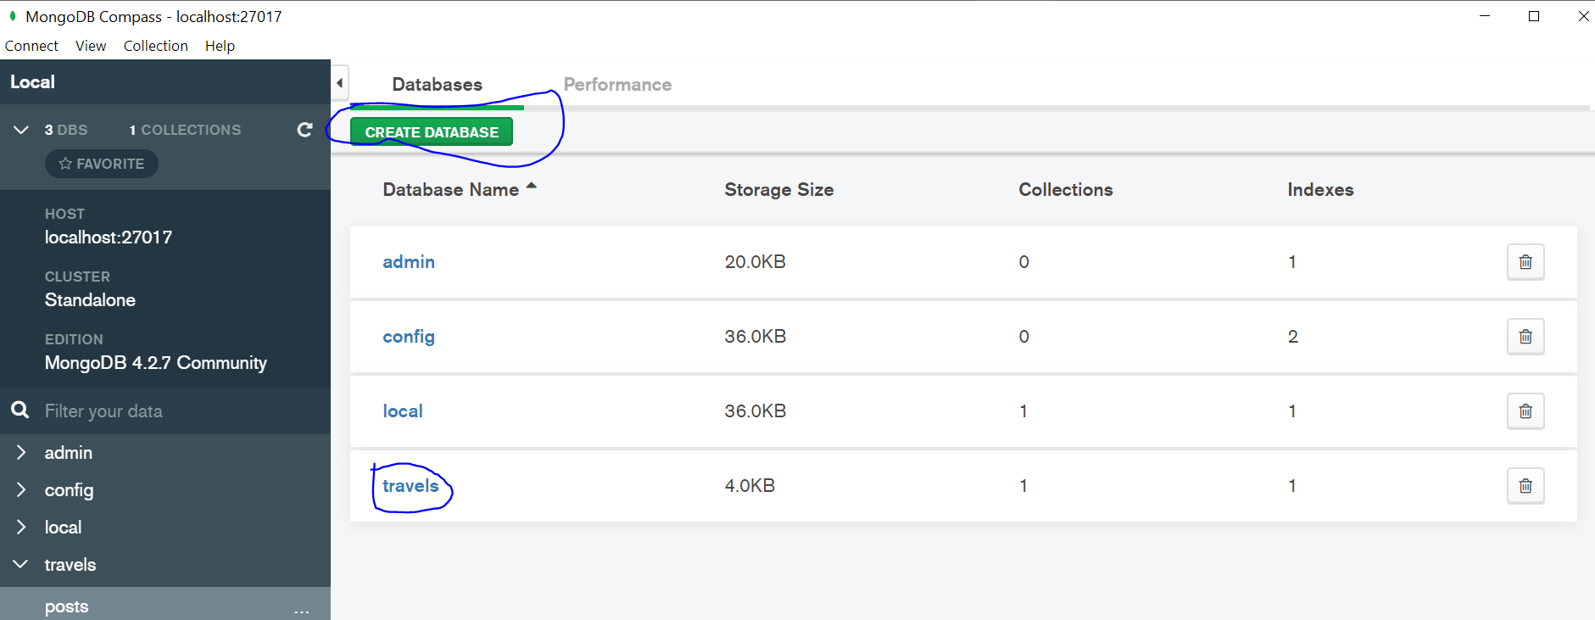
3. Now we need to create Schema for that we need to use Mongoose, at the VSCode terminal type npm I mongoose.
4. 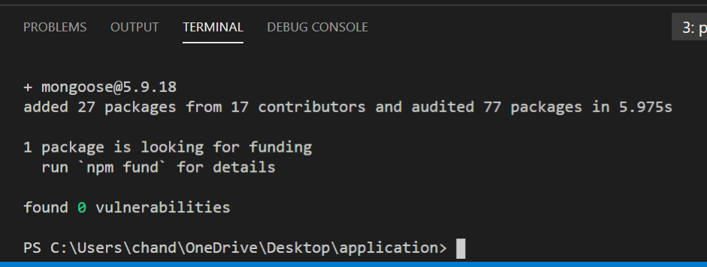
5. Now need to connect mongoose to app.js so write a script in app.js as:
6. 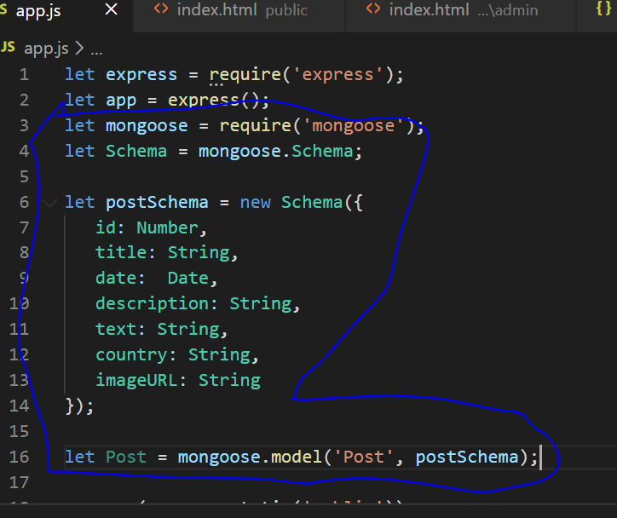
7. Now create a folder models in application folder and create a file posts.js under models.
8. 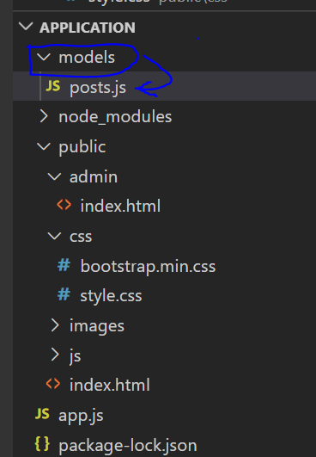
9. Now cut the script from app.js and paste it in posts.js under models also add
10. Module.export = { Post} so that other files can use this script as it’s on different module.
11. 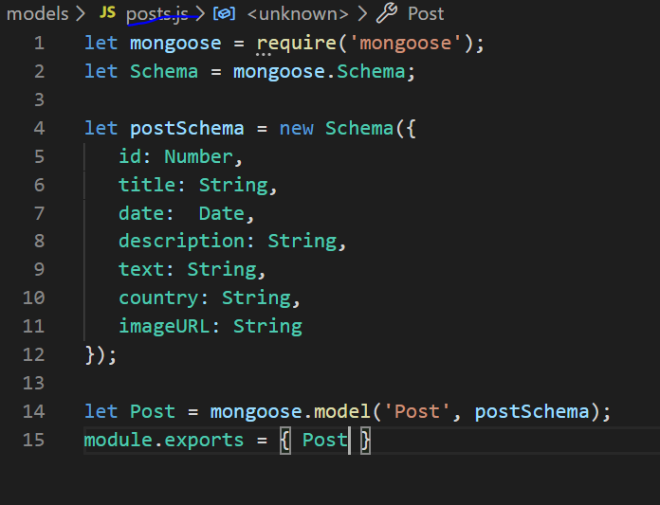
12. 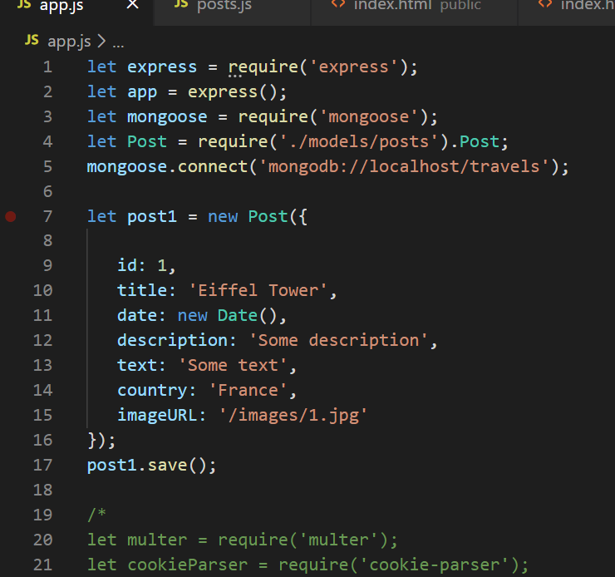
13. 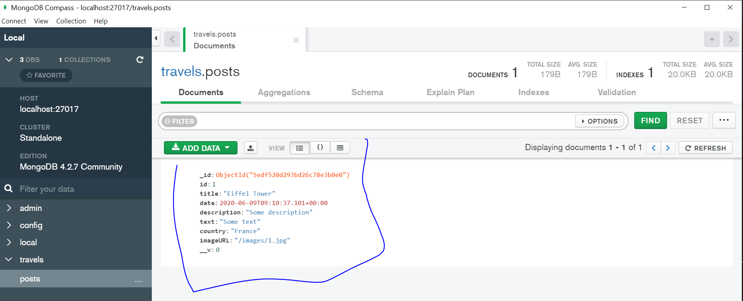
14. Now add different info and save and run node.js you’ll see this in compass:
15. 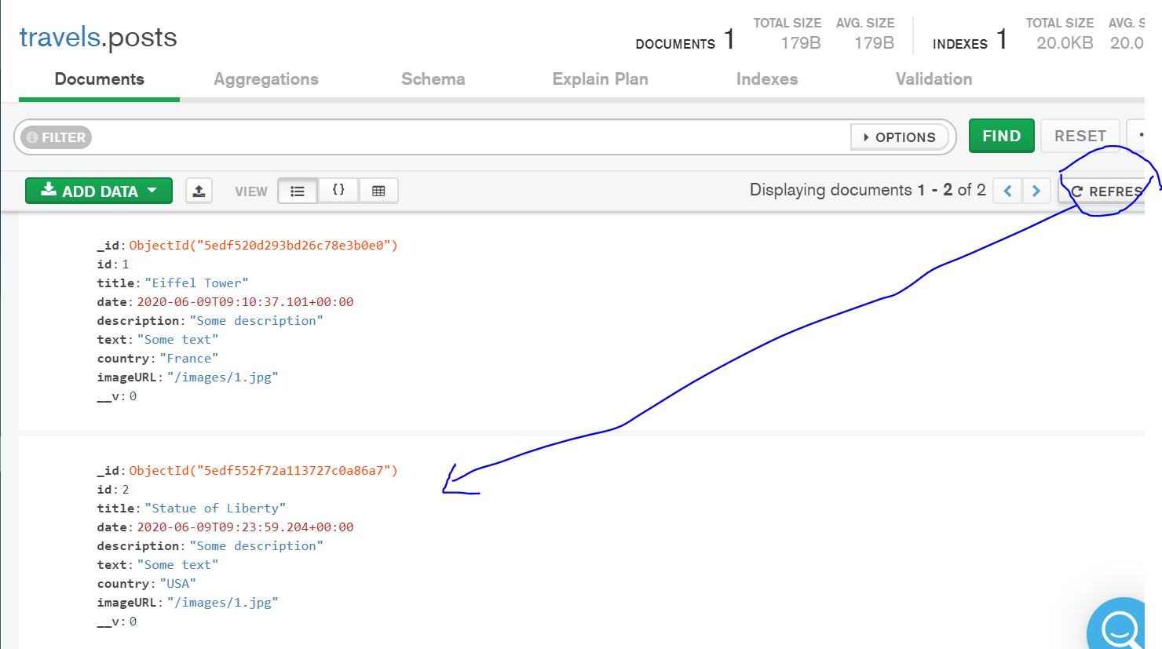
16. Sec276: (Need more details so review the videos again)
17. Now add the below script to app.js to connect to database:
18. 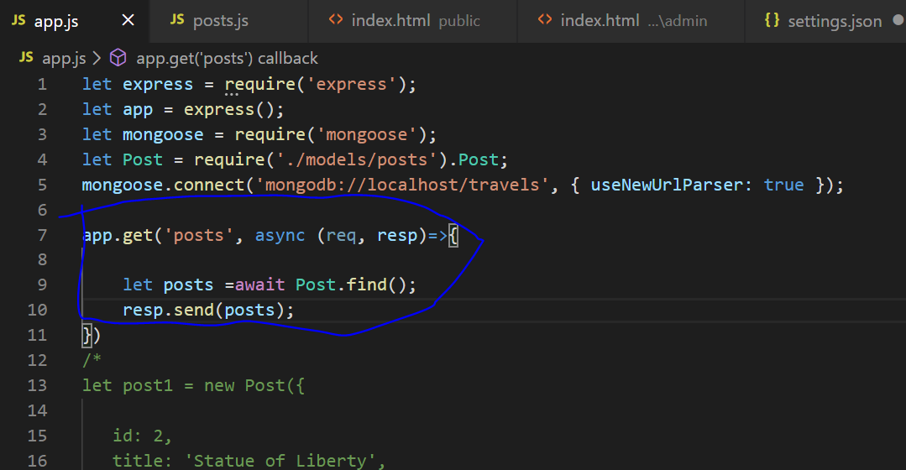
19. Create a folder posts.js under js file:
20. 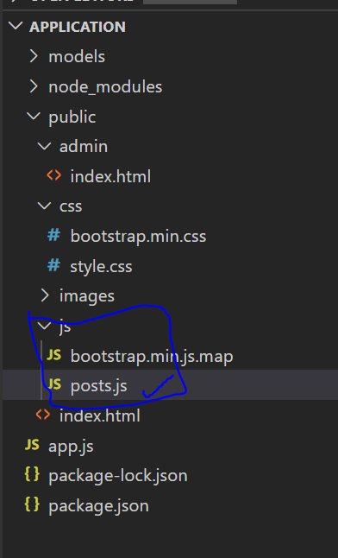
21. Here in posts.js we are going to write all functions for post.:
22. Now type this script:
23. 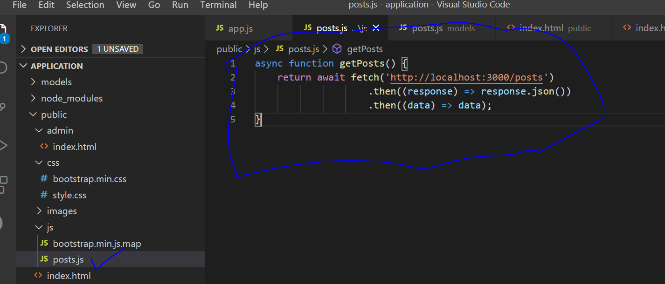
24. Now we have to connect the posts.js file to admin page, so go to index.html file in admin and add the link as below before the </body>:
25. 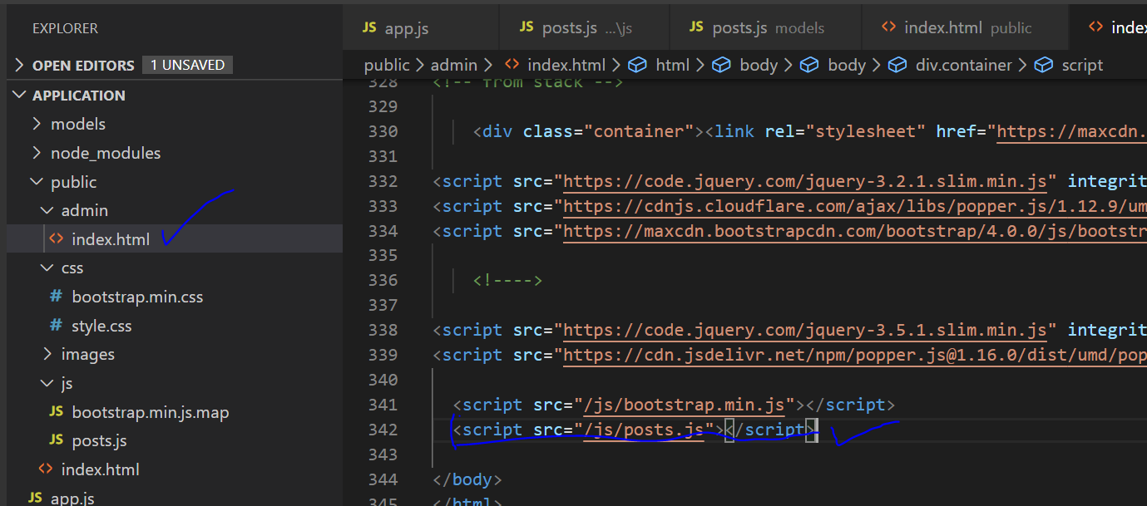
26. Now whenever the user clicks on Admin Page the get posts function (point 125) or on the the posts.js file gets called.
27. Now lets create a js **folder** under admin folder where all admin related files are stored.
28. Lets start with creating main.js **file** under js folder under admin folder:
29. 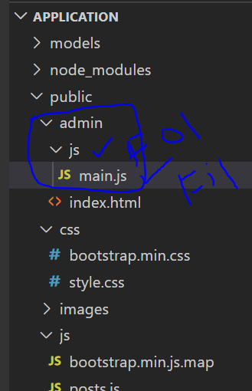
30. Now let’s connect the main.js file to admin page via adding a link to index.html file under admin folder:
31. 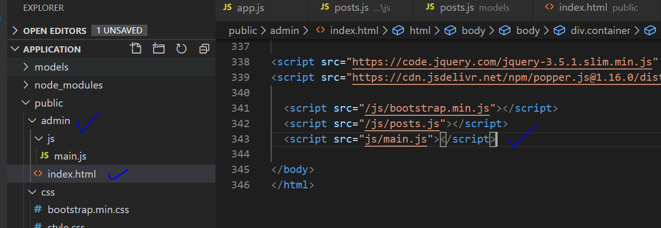
32. Above we just used js/main.js instead of /js/main.js as main.js and index.html are on same path as admin.
33. When the admin page opens all the posts should be downloaded and inserted to the admin page ie the post sent from the user should get on the admin page . But how do we know that the admin page is opened..for that we object document which has an event called ‘DOMContentLoaded’ this event happens when the object document is completely loaded.
34. So here we can do some action which is getposts function can be called as below:
35. document.addEventListener('DOMContentLoaded', async function() {
36. let posts = await getPosts();
37. This will give an array of all post stored in the database since it’s an array we can use the for each function:
38. 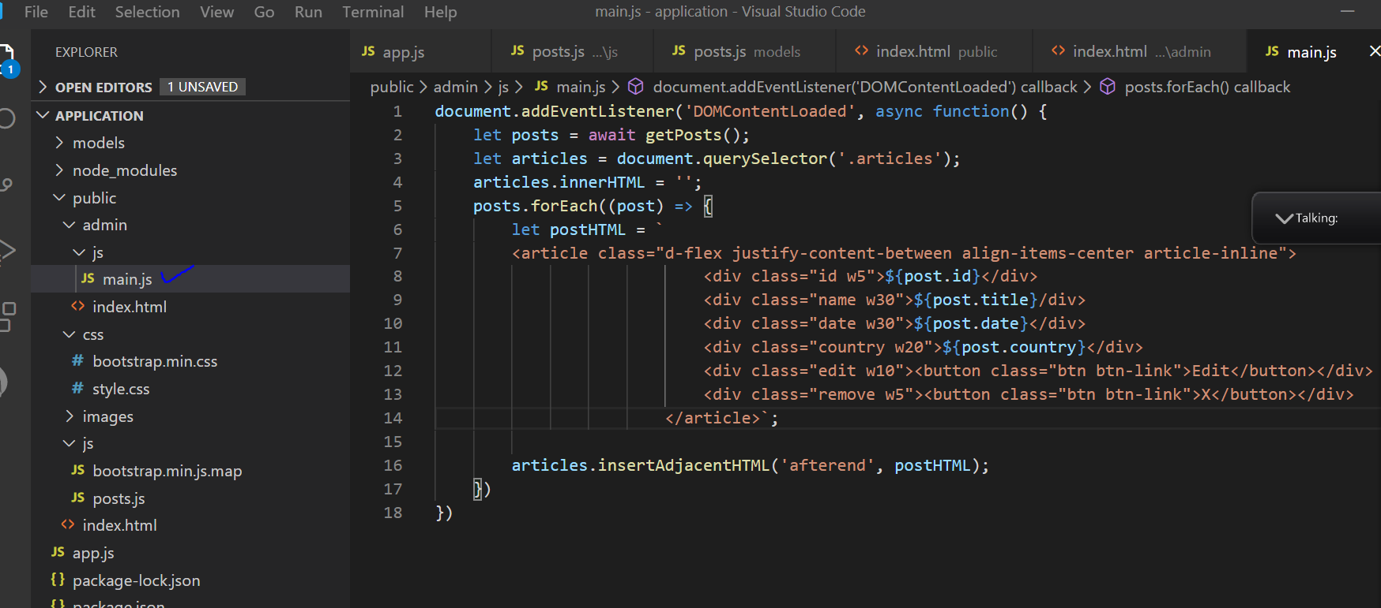
39. Now we can delete the articles created previously manually under index.html.
40. 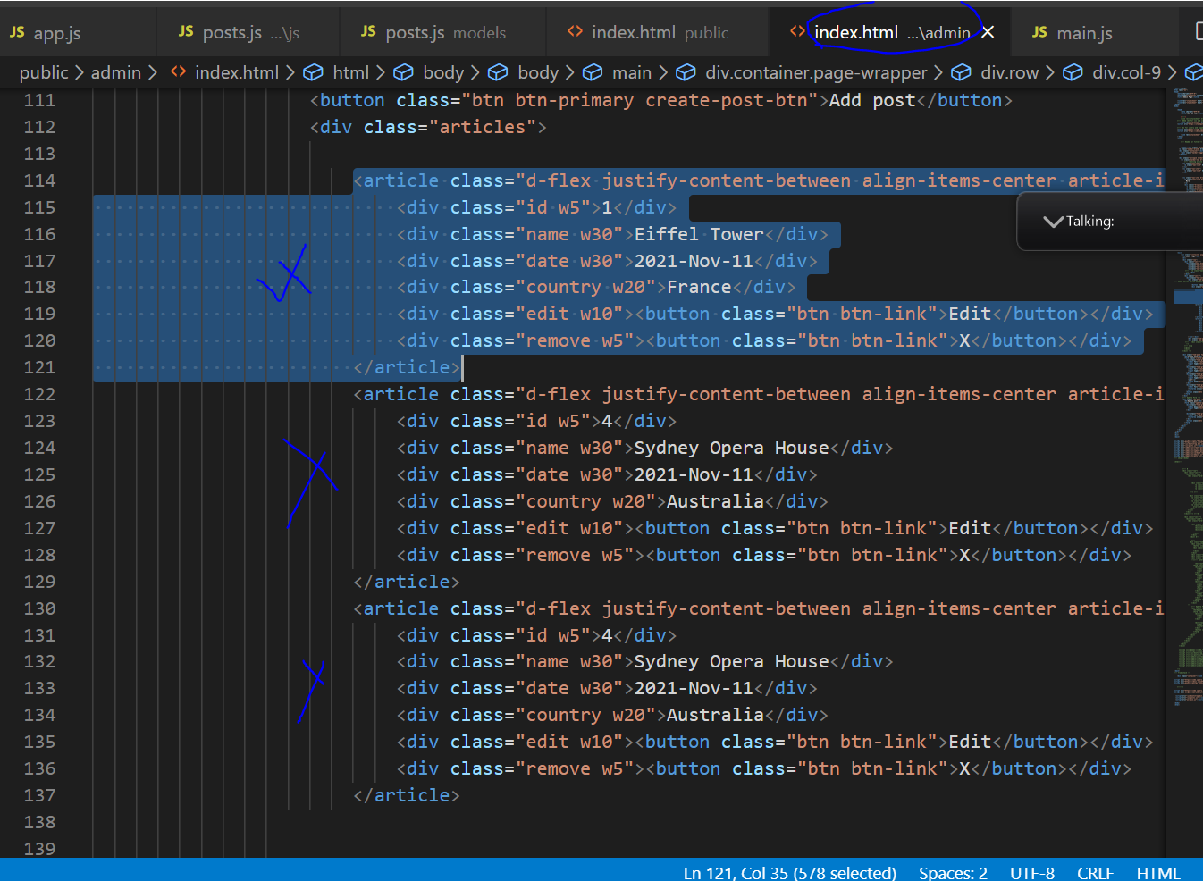
41. Now run node app.js in Vscode terminal and checl the browser for the admin page:
42. 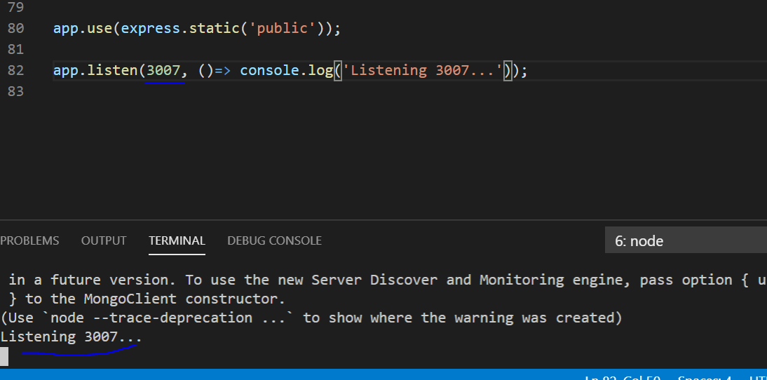
43. Sec 277 Creating Posts part 1:
44. Goto to Public->Admin-index.html and make the below changes:
45. 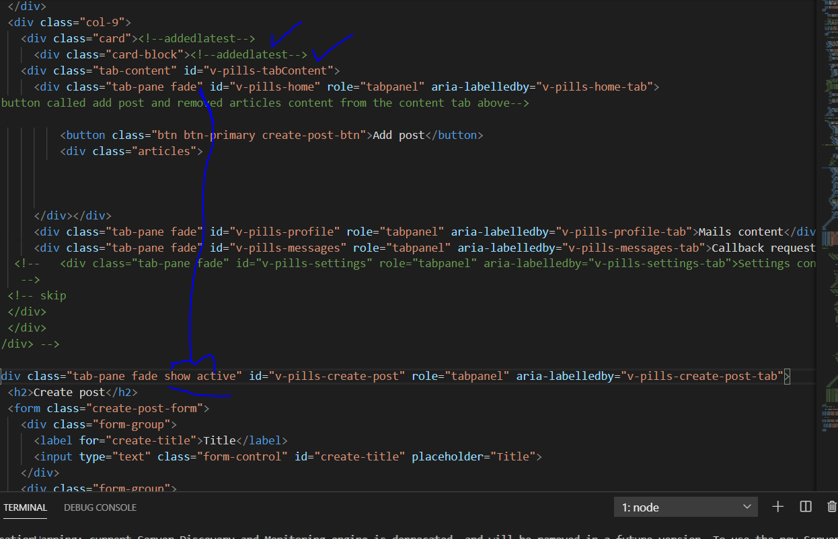
46. We get this:
47. 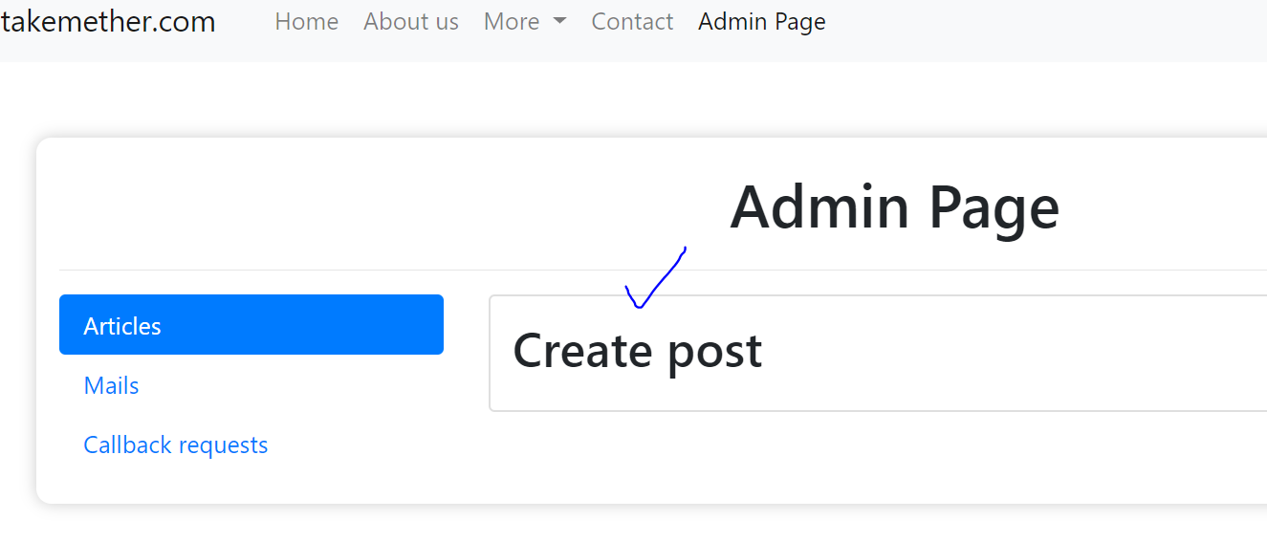
48. Now remove show active and place it back at it’s original place.
49. 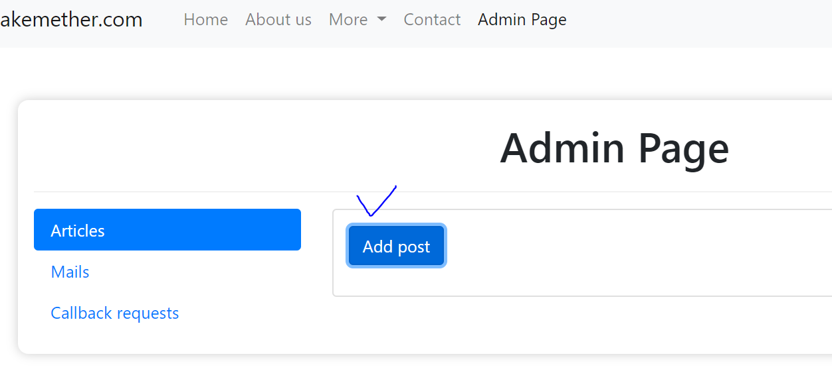
50. Changed these names from the original
51. 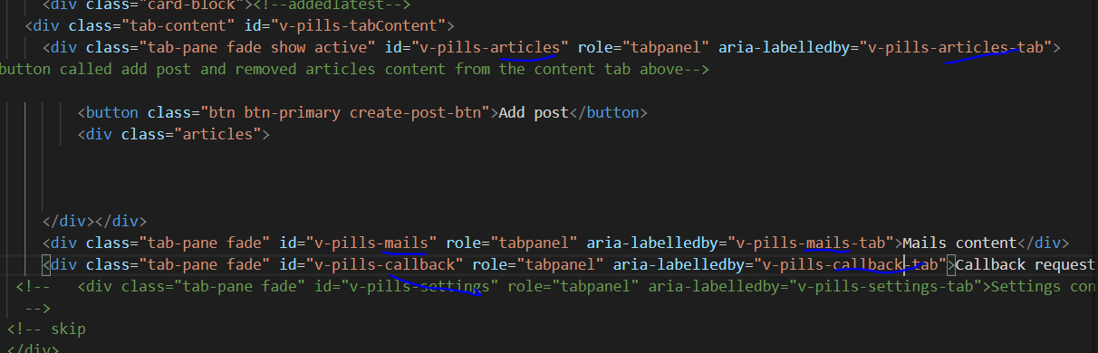
52. Made these changes:
53. 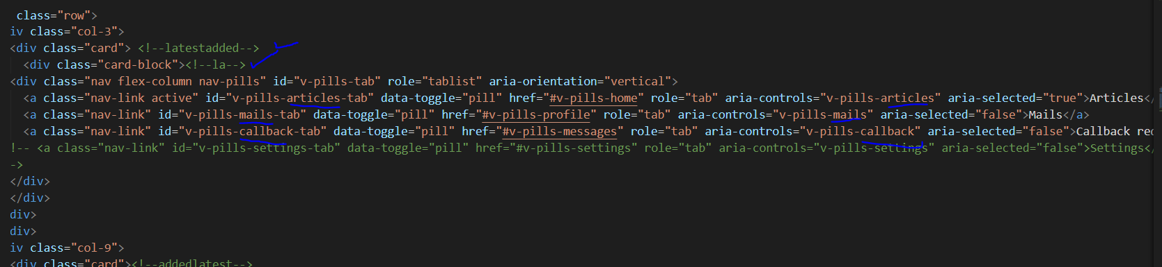
54. 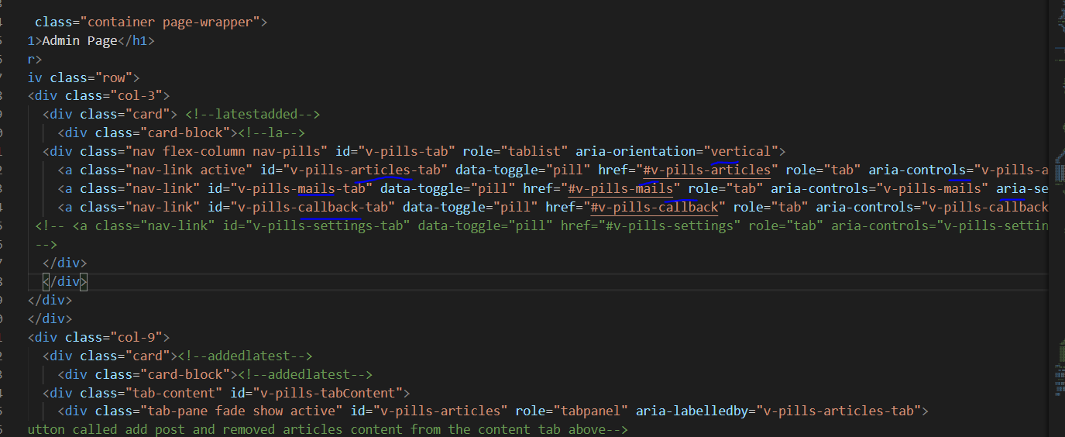
55. 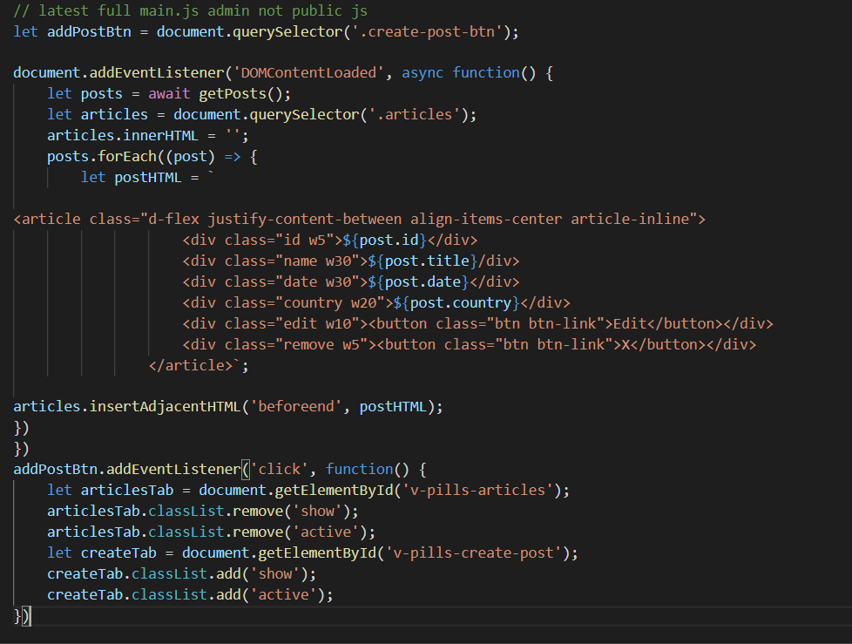
56. Now we create form using bootstrap off website go to forms and choose as below:
57. 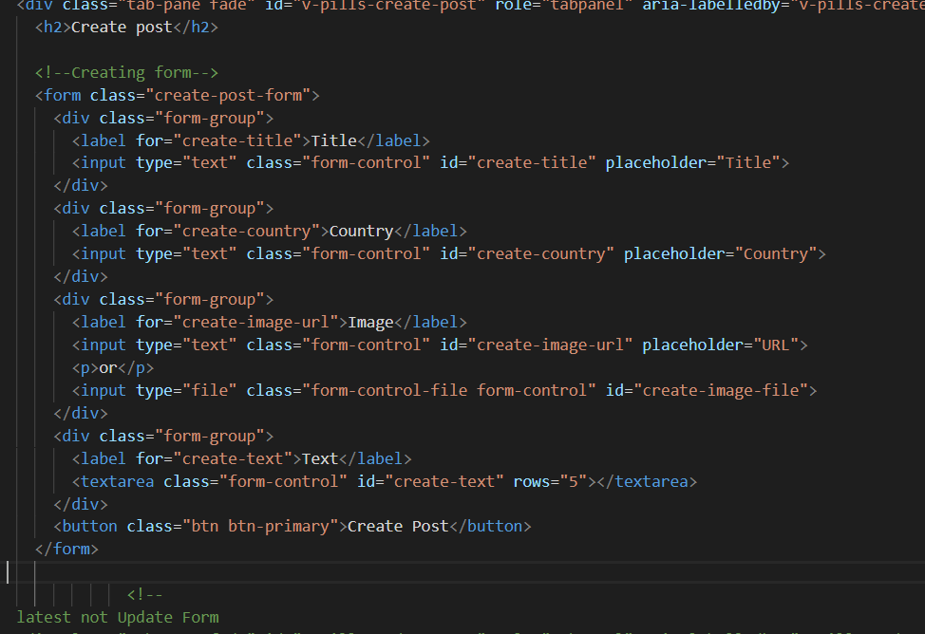
58. We get:
59. 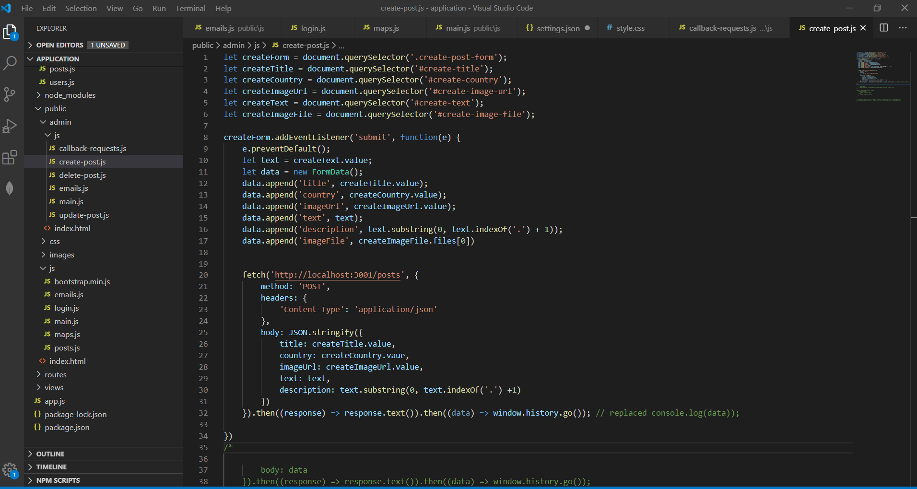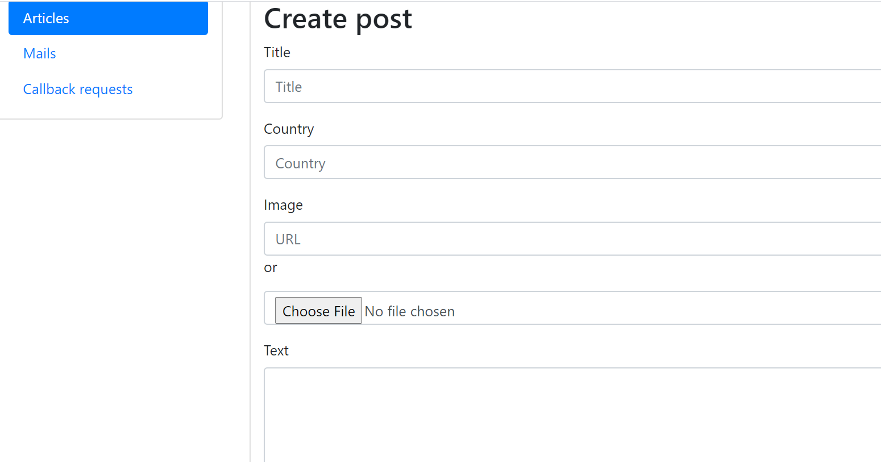
60. Sec 278:
61. 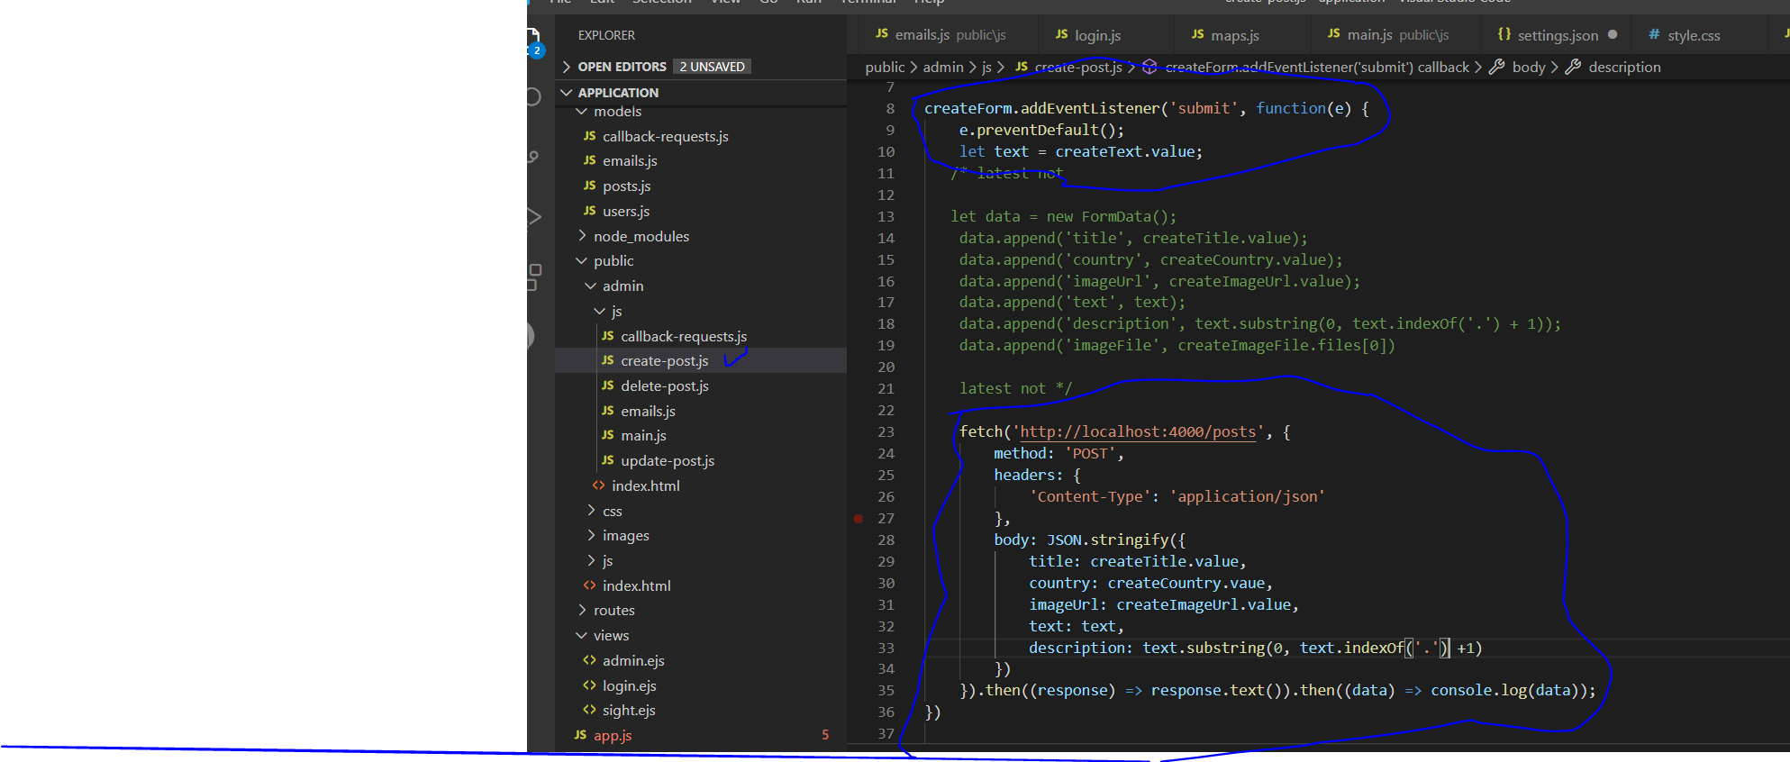
62. App.js:
63. 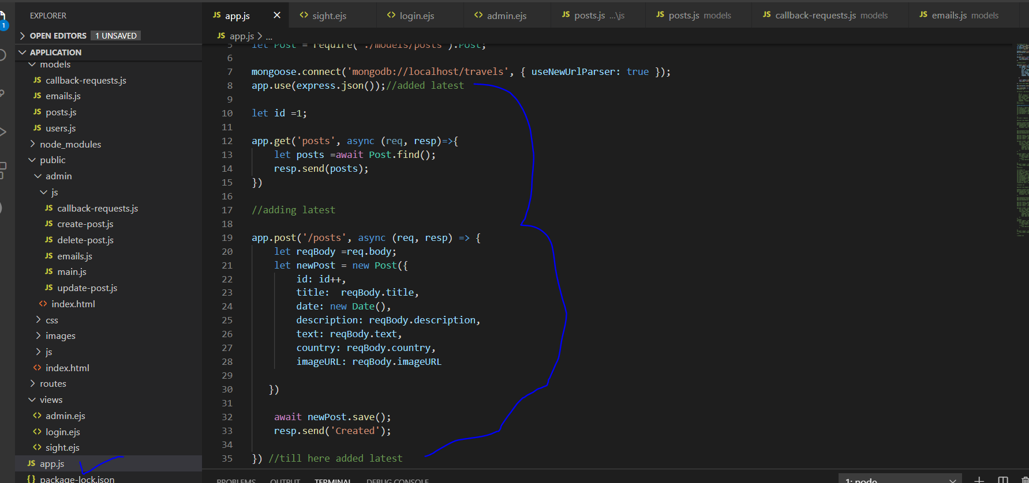
64. 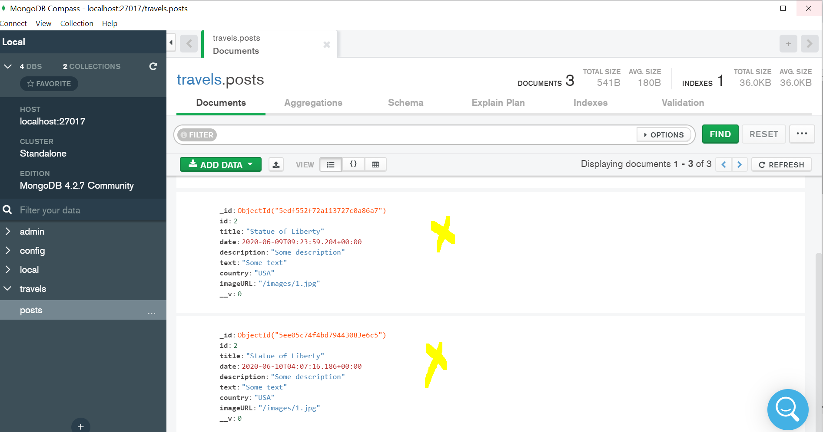
65. 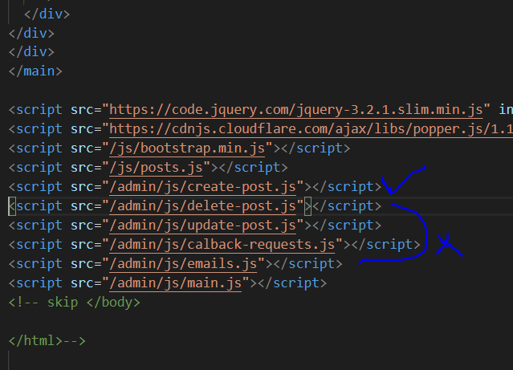
66. 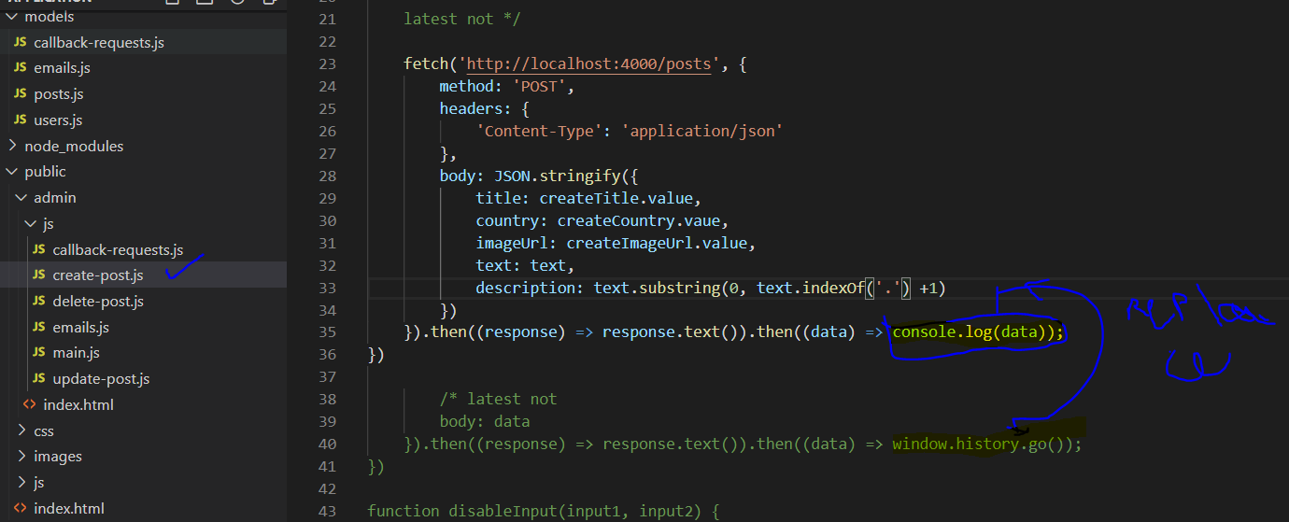
67. Sec 275 connecting to data base by typing mongod in vscode terminal refresh:
68. 